7.3 Stormwater Best Management Practices and Prioritization

The two primary land uses in the Neshanic River Watershed are agriculture and urban with urban consisting of residential, commercial and industrial. For the urban land use, three primary stormwater best management practices (BMPs) are being recommended to address the total phosphorus and pathogen contamination in the watershed: Rain Gardens, Detention Basin Retrofits, and Roadside Ditch Retrofits. Each of these recommended BMPs is described in the following pages.

Water quality and flow data were collected at seven sampling stations. These data were used to determine the pollutant loads from each of the subwatersheds whose outlet is represented by each of the seven sampling locations. These data were used to rank the subwatersheds by total phosphorus and fecal coliform loads. These results are presented in the following pages.

Although total phosphorus and fecal coliform contamination is prevalent through the entire watershed, ranking of the subwatersheds and existing stormwater infrastructure will provide the stakeholders within the region a prioritization strategy for addressing the nonpoint source pollution problems within the watershed. One strategy would be to focus all efforts on the highest priority subwatershed. For example, Subwatershed N1 received the highest ranking for both total phosphorus and fecal coliform. One strategy would be to use the detention basin and roadside ditch rankings to identify the best opportunities within this subwatershed and begin implementing the recommended solutions for this existing stormwater infrastructure. Included in this strategy would be to begin installing rain gardens throughout Subwatershed N1 to continue to reduce the pollutant loading in the highest priority subwatershed. A second strategy would be to focus restoration efforts on the highest ranking detention basins or roadside ditches in all seven watersheds. Either strategy should yield quick results in reducing pollutant loads to the Neshanic River.

For the BMP sections, pollutant load reductions were determined when data were available for these calculations. For example, we know that a rain garden can be designed to capture, treat and infiltrate stormwater runoff from 1,000 square feet of impervious surface at each residential property. We also know that these rain gardens would capture 90% of the annual stormwater runoff from this 1,000 square foot area. Finally, we can assume an aerial loading of total phosphorus, total nitrogen, and total suspended solids for this land use and calculate the reduction in this load that would result from the rain garden treating the stormwater runoff. Additionally, we also have a fairly good idea of the range of costs to build this rain garden. For retrofitting detention basins, the pollutant load reduction cannot be calculated since the drainage area for each detention basin is unknown; expected load reduction percentages for different pollutants are available, though.

Site specific field data must be collected to complete all rain garden, detention basin retrofit and roadside ditch retrofit designs. Soil type and infiltration rates are very important parameters that must be considered, as well as drainage areas to properly size these designs. The following pages should not be used as a substitute for preparing final engineering designs of these BMP projects.
Subwatershed Priority Ranking

One of the goals of the watershed restoration plan is to prioritize the implementation of various best management practices. For this project, water quality data and flow data were collected at seven sampling locations. Each of these sampling locations represents the outlet of a subwatershed within the Neshanic River Watershed. To identify which subwatershed was contributing the most pollution to the Neshanic River, data from each of these sampling locations was used to determine the annual pollutant load leaving each of the subwatersheds. The subwatersheds were then ranked by their annual pollutant load.

The two primary pollutants of concern in the Neshanic River Watershed are total phosphorus and fecal coliform, which is an indicator of pathogen contamination. Flow and pollutant concentration from each sampling event were used to calculate the load for each sampling event at each sampling location. The annual total load for each subwatershed was determined by averaging the daily loads and multiplying this average daily load by 365 days (number of day in a year). For total phosphorus, this provides an annual load in kg/year. For fecal coliform, this calculation provided an annual load in colonies per year. These annual loads are presented in Table 1.

Since each subwatershed is different in size, the annual loads were then normalized by dividing them by the number of acres in each subwatershed. This provides a total phosphorus loading rate in terms of kg/year/acre and a fecal coliform loading rate in terms of colonies/year/acre. These loading rates are provided in Table 2.

The annual loads and loading rates were used to rank the subwatersheds. The subwatershed with the highest loading rate was given 7 points, the next highest was given 6 and so on. This method was repeated for the area normalized loading rate. The points were combined and the subwatersheds were ranked highest to lowest according to their total points. These results are presented in Table 3 for total phosphorus and Table 4 for fecal coliform.

The loading rate shows which subwatershed is contributing the most pollutants into the stream. The area normalized loading rates show which subwatershed is contributing the most pollutant per acre. Combining both parameters ensures that the subwatersheds with the highest priority are those where the greatest impact can be had with the least amount of implementation. See Table 5 and 6 for ranking results.

The final step in this analysis was to combine the priority rankings for total phosphorus and fecal coliform to create an overall ranking for each subwatershed. These results are shown in Table 7. Subwatersheds N1 and TN3a were ranked the highest priority while FN1 and UNT1 were ranked the lowest priority. These ranking will help prioritize the implementation of stormwater best management practices and agricultural management practices. By focusing implementation strategies on Subwatersheds N1 and TN3a, the maximum pollutant load reductions can be obtained to improve the Neshanic River and achieve the TMDL.

Table 1: Annual Load for Fecal Coliform and Total Phosphorus

Subwatershed | Fecal Coliform  (Colonies/yr) | Total Phosphorus (kg/yr)
N1 | 1.94E+14 | 525.98
TN3a | 4.51E+13 | 174.71
SN1 | 2.56E+13 | 165.32
TN3 | 2.42E+12 | 84.42
FN1 | 2.23E+13 | 70.21
UNT2 | 2.89E+13 | 47.48
UNT1 | 4.56E+12 | 33.93

Table 2: Aerial Loading Rates for Fecal Coliform and Total Phosphorus

Subwatershed | Fecal Coliform  (Colonies/yr/acre) | Total Phosphorus (kg/yr/ac)
N1 | 6.83E+10 | 0.18
TN3 | 3.47E+09 | 0.12
UNT2 | 2.97E+10 | 0.05
SN1 | 6.66E+09 | 0.04
TN3a | 7.63E+09 | 0.03
UNT1 | 4.67E+09 | 0.03
FN1 | 7.43E+09 | 0.02

Table 3: Ranking Subwatersheds by Total Phosphorus Annual Loads and Loading Rates

Subwatershed | Annual Load  (kg/yr) | Ranking of Annual Load | Annual Loading Rate (kg/yr/ac) | Ranking of Annual Loading Rate | Summation of Rankings
N1 | 525.98 | 7 | 0.18 | 7 | 14
TN3 | 84.42 | 4 | 0.12 | 6 | 10
SN1 | 165.32 | 5 | 0.04 | 4 | 9
TN3a | 174.71 | 6 | 0.03 | 2 | 8
UNT2 | 47.48 | 2 | 0.05 | 5 | 7
FN1 | 70.21 | 3 | 0.02 | 1 | 4
UNT1 | 33.93 | 1 | 0.03 | 3 | 4

Table 4: Ranking Subwatersheds by Fecal Coliform Annual Loads and Loading Rates

Subwatershed | Annual Load  (Colonies/yr) | Ranking of Annual Load | Annual Loading Rate (Colonies/yr/ac) | Ranking of Annual Loading Rate | Summation of Rankings
N1 | 1.94E+14 | 7 | 6.83E+10 | 7 | 14
TN3a | 4.51E+13 | 6 | 7.63E+09 | 5 | 11
UNT2 | 2.89E+13 | 5 | 2.97E+10 | 6 | 11
SN1 | 2.56E+13 | 4 | 6.66E+09 | 3 | 7
FN1 | 2.23E+13 | 3 | 7.43E+09 | 4 | 7
UNT1 | 4.56E+12 | 2 | 4.67E+09 | 2 | 4
TN3 | 2.42E+12 | 1 | 3.47E+09 | 1 | 2

Table 5: Priority Ranking Subwatersheds by Total Phosphorus

Subwatershed | Ranking of Annual Load | Ranking of Annual Loading Rate | Overall Rankings
N1 | 7 | 7 | 1
TN3 | 4 | 6 | 2
SN1 | 5 | 4 | 3
TN3a | 6 | 2 | 4
UNT2 | 2 | 5 | 5
FN1 | 3 | 1 | 6
UNT1 | 1 | 3 | 7

Table 6: Priority Ranking Subwatersheds by Fecal Coliform

Subwatershed | Ranking of Annual Load | Ranking of Annual Loading Rate | Overall Rankings
N1 | 7 | 7 | 1
TN3a | 6 | 5 | 2
UNT2 | 5 | 6 | 3
FN1 | 3 | 4 | 4
SN1 | 4 | 3 | 5
UNT1 | 2 | 2 | 6
TN3 | 1 | 1 | 7

Table 7: Overall Priority Ranking Subwatersheds by Fecal Coliform and Total Phosphorus

Subwatershed | Overall Phosphorus  Ranking | Overall  Fecal  Ranking | Overall Combined Rankings | Overall  Priority  Ranking
N1 | 14 | 14 | 28 | 1
TN3a | 8 | 11 | 19 | 2
UNT2 | 7 | 11 | 18 | 3
SN1 | 9 | 7 | 16 | 4
TN3 | 10 | 2 | 12 | 5
FN1 | 4 | 7 | 11 | 6
UNT1 | 4 | 4 | 8 | 7

Rain Gardens

Current Conditions

The Neshanic River Watershed has been listed in the New Jersey Integrated Water Quality Monitoring and Assessment Report, which includes the 305(b) Report and 303(d) List, as being impaired for total phosphorus and total suspended solids (TSS). A significant source of total phosphorus and TSS is stormwater runoff from residential communities. Sources of pollutants are typically roadway sediment and lawn fertilizer, as well as soil erosion from unstable areas.

Traditional stormwater management techniques promote end-of-the pipe treatment of stormwater at a centralized location, typically a detention basin. These stormwater management facilities are often large in size, occupy one or more acres of land and typically require regular maintenance such as weekly mowing. Additionally, detention basins are limited in their ability to remove phosphorus and TSS, as pollutant removal processes within these systems are limited to settling. An effective and less costly approach is to build multiple smaller stormwater best management practices (BMPs) such as rain gardens to capture and treat pollutants at the source, rather than to build a single large end-of-the-pipe stormwater management facility.

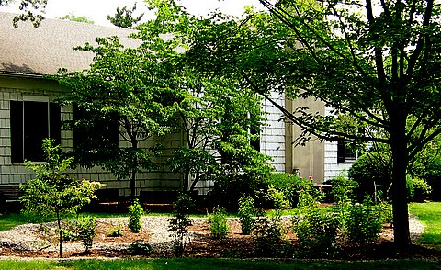
General Description
Figure 1: Home Rain Garden

A rain garden is a landscaped, shallow depression designed to capture, treat, and infiltrate stormwater at the source before it becomes runoff (See Figure 1). Plants used in the rain garden help retain pollutants that could otherwise degrade nearby waterways. Rain gardens are becoming popular in suburban and urban areas. These systems not only improve water quality, but also help homeowners minimize the need for watering and fertilizing large turf grass areas and promote groundwater recharge. If designed properly, these systems improve the aesthetics of the urban/suburban neighborhoods through the use of flowering native plants and attractive trees and shrubs.

A typical rain garden is designed to capture, treat and infiltrate the water quality storm of 1.25 inches of rain from a 1,000 square foot impervious area from an individual lot (i.e., a 25 ft by 40 ft roof for a house or a 20 ft wide by 50 ft long driveway). By collecting runoff generated by the first 1.25 inches of rainfall, the rain garden prevents the “first flush” of runoff from entering the stream, which characteristically has the highest concentration of contaminants. For the water quality storm of 1.25 inches of rainfall, the rain garden needs to be 10 ft by 20 ft and six inches deep. Since 90% of all rainfall events are less than one inch, rain gardens are able to treat and recharge a majority of runoff from these storms. If forty homes incorporated rain gardens to treat runoff from 1,000 square feet of impervious areas (rooftops, sidewalks, patios, and driveways), the result would be over one million gallons of stormwater being recharged each year.

Residential Rain Gardens

Although residential rain gardens can be designed to manage stormwater runoff from highly fertilized turf areas, residential rain gardens typically are designed to treat stormwater runoff from a roof downspout or from a driveway or patio. Although runoff from these areas is typically low in pollutants, rain gardens help to manage stormwater flows, reducing the volume of runoff during each storm. By capturing and recharging stormwater, residential rain gardens in a community can collectively help reduce stream flows during storm events, minimizing stream bank erosion and scouring of the streambed. This reduction in the flashy hydrology of the stream ultimately reduces TSS and phosphorus loads that come from the eroding stream banks.

Residential rain gardens are often placed in easements, and deed restrictions are place on them so that they cannot be eliminated when property transfers ownership. The homeowner is responsible for maintaining the condition of the rain garden. It is this responsibility that encourages the homeowner to learn about the importance of stormwater management.
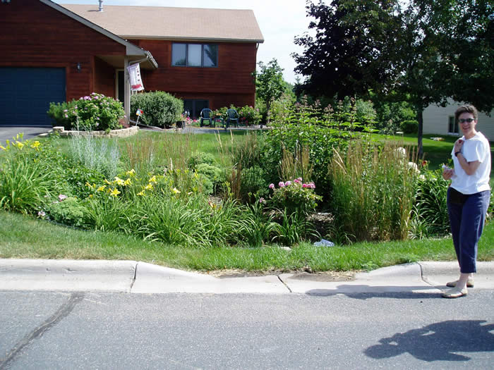
Figure 2: Road Rain Garden (http://www.minnehahacreek.org)

Roadway Rain Gardens

Rain gardens can also be used to capture, treat and infiltrate runoff from roadways (See Figure 2). Roadway rain gardens are usually built in the existing right-of-way of a local road or on a purchased easement. These gardens are publicly owned and can be maintained by the municipality or county that owns the roadway, or they can be given to homeowners to maintain in a similar way that homeowners mow the lawn in the right-of-way or shovel the sidewalks in the right-of-way. Many homeowners agree to take on the maintenance responsibilities because these gardens can improve the landscaping of their property, thereby increasing the value of their home. Since runoff from roadways has been shown to have high concentrations of TSS and phosphorus, roadway rain gardens can substantially reduce TSS and phosphorus loading to the local waterways.

Proposed Locations

Rain gardens are excellent systems for retrofitting urban and suburban areas. With relative ease, they can be incorporated into existing landscapes to capture, treat and infiltrate stormwater runoff from impervious and pervious surfaces. They can be used in full or partial sunlight or in completely shaded areas. They are inexpensive to build and relatively easy to maintain. They can be built to discharge to the underlying groundwater or to an underdrain system that carries the treated stormwater runoff to a local waterway or storm sewer system.

There are over 4,000 acres of the Neshanic River Watershed that are classified as residential land use. Many of these communities would be ideal locations for rain gardens as a means of source control to better manage TSS and phosphorus loads, as well as reducing stormwater runoff volumes. For each of the subwatersheds in the study area, residential development sites have been identified as candidates for retrofitting with rain gardens. These residential development sites are shown in the figures of Appendix A and summarized in the tables found in Appendix B. In addition to the identified residential development sites, individual homes were also counted in each subwatershed to determine other potential locations for rain gardens. Table 8 shows the total number of houses in each subwatershed.

Table 8: Total Number of Houses in Each Subwatershed for Possible Retrofitting with Rain Gardens

Subwatershed | Total # of Houses
FN1 | 753
SN1 | 657
TN3 | 47
TN3a | 405
N1 | 915
UNT1 | 445
UNT2 | 323

Implementation

There are several methods to begin implementation of rain garden programs that can effectively manage stormwater runoff from residential areas, roadways, commercial and industrial sites. One avenue is to educate the general public through effective outreach programming. These programs would involve classroom instruction, as well as hands-on building of rain gardens. Past experiences have indicated that when the public is engaged in actually constructing a rain garden as part of an outreach program, they are more likely to build one at their own residence.

A second approach would be to train landscape professionals on the installation and maintenance of rain gardens. This will provide the landscapers an additional item to offer their environmentally conscience clients or clients that are required to offset exceedences in local impervious cover limits due to an addition to their home or a patio. An effective training programming of landscape professionals, coupled with an educational program on rain gardens, would expand the use of rain gardens in the watershed.

A third alternative would be to have the municipalities and their Department of Public Works install rain gardens to capture roadway runoff. This would be a very effective program but require buy-in from local residents so that they will maintain the gardens after construction. Additionally, tax incentives could be provided to homeowners to encourage the incorporation of a rain garden into their roadside landscape.

The Rutgers Cooperative Extension Water Resources Program has been providing effective outreach programs on rain gardens for the general public, as well as landscapers and municipal officials, throughout New Jersey. Outreach efforts to educate the public about stormwater infrastructure can be provided by the Rutgers Cooperative Extension Water Resources Program. This would include installing rain gardens on private and public properties (as a roadway or residential rain garden). It is important to get the public involved in the beginning and to keep their attention. Rain gardens will change the way neighborhoods look, and residents need to understand the benefits to the community. After homeowners are educated about rain gardens and are excited about the benefits these systems can provide, specific properties need to be identified for rain garden retrofits. Specific rain garden designs will be created for each site with the input of local residents. Construction of a rain garden will include limited excavation, soil amendments, and planting. A curb cut may be necessary if a roadway rain garden is installed in a curbed community. A typical residential rain garden can be constructed in a single day.

Rain gardens need to be inspected for clogging and excessive debris and sediment accumulation at least four times a year, as well as after every storm exceeding one inch of rainfall. Sediment removal should take place when the garden is thoroughly dry. Disposal of debris, trash, sediment, and other waste material should be done at suitable disposal/recycling sites and in compliance with all applicable local, state, and federal waste regulations (Semple et al., 2004).

Vegetated areas should also be inspected at least once a year for unwanted growth. Weedy plants should be removed with minimum disturbance to the planting soil bed and remaining vegetation. When establishing or restoring vegetation, biweekly inspections of vegetation health should be performed during the first growing season or until the vegetation is established. Once established, inspections of vegetation health, density, and diversity should be performed during both the growing and non-growing season at least twice a year. All use of fertilizers, mechanical treatments, pesticides and other means to assure optimum vegetation health must not compromise the intended purpose of the rain garden system. All vegetation deficiencies should be addressed without the use of fertilizers and pesticides whenever possible. The rain garden should be inspected for excess ponding after significant storm events. Corrective measures should be taken when excessive ponding occurs (Semple et al., 2004).

The system’s drain time should be evaluated after rain storms larger than one inch. If the drain time is longer than 72 hours, the system needs to be evaluated to find a way to decrease the drain time to at least 72 hours, which is the maximum drain time allowed by NJDEP (Semple et al., 2004).

Prioritization

The subwatershed ranking for greatest need of rain gardens has been based on the phosphorus ranking (See priority sheet for ranking).

Rain gardens can be installed almost anywhere. Ideally the best installation sites are those where the soils are well-drained so that an underdrain system is not required. Municipalities can partner with Rutgers Cooperative Extension, local environmental organizations, environmental commissions and other community organizations to reach out to home and business owners to identify target neighborhoods willing to have rain gardens installed on their property and maintain them for the town.

Cost

Rain gardens can be very inexpensive if constructed by the homeowner. Typically, for as low as $2 to $4 per square foot, a residential rain garden can be installed. To have a landscaper install a rain garden at a home can be as much as $5 to $10 per square foot. For a typical residential rain garden (approximately 200 square feet), the cost would be $1,000 to $2,000 if installed by a landscaper or $400 to $800 if installed by a homeowner.

Expected Results

Rain gardens are designed to treat only small storms, but these events make up the majority of storms throughout a given year. It is fair to assume, if designed correctly, rain gardens will reduce the pollutant loading from a drainage area by 90% wherever they are installed. Furthermore, they will reduce stormwater runoff volumes and reduce the flashy hydrology of local streams. This reduction of flashy hydrology will minimize stream bank erosion and stream bed scour, thereby reducing TSS and phosphorus loads in the waterway. According to Rusciano 2007, rain gardens are found to remove 90% of fecal coliform from stormwater runoff.

If we assumed that each home (3,545 homes) identified in Table 8 installed a rain garden to capture, treat and infiltrate runoff from 1,000 square feet of impervious surfaces, over 88 million gallons of stormwater runoff would be captured, treated and infiltrated. Assuming that this area is low density residential and aerial loading coefficients are 0.6, 5.0 and 100 pounds per acre per year of total phosphorus, total nitrogen, and total suspended solids, respectively, we can calculate the total pounds of total phosphorus, total nitrogen and total suspended solids removed by the rain gardens as 44, 366, and 7,324 per year. The total cost would be $1.4 million if each garden was installed by the homeowner at $2 per square foot (assuming a 200 square foot rain garden) or $7.1 million if each rain garden cost $2,000 and was installed by a landscape professional.

These reductions assume a 100% adoption of rain gardens by homeowners. Table 9 illustrates various scenarios for a lower homeowner adoption. The cost would proportionally decreases based upon the number of homes that adopt rain gardens. It is important to note that these calculations are only for residential rain gardens. There may be additional locations throughout the watershed where commercial and industrial properties can install rain gardens and achieve similar load reductions. Rain gardens associated with roadside runoff are discussed in the section about retrofitting roadside ditches.

Table 9: Possible Annual Pollutant Load Reduction and Volume of Water Captured and Infiltrated Based Upon Various Scenarios of Homeowner Adoption of Rain Gardens throughout the Neshanic River Watershed
% of Homes with Rain Gardens | Total Phosphorus Removed  (lbs/yr) | Total Nitrogen  Removed  (lbs/yr) | Total Suspended Solids Removed  (lbs/yr) | Volume of Water Captured and Infiltrated  (MG/yr)
25% | 11 | 92 | 1,831 | 22
50% | 22 | 183 | 3,662 | 44
75% | 33 | 275 | 5,493 | 66
100% | 44 | 366 | 7,324 | 89

Detention Basin Retrofit Designs

Current Conditions

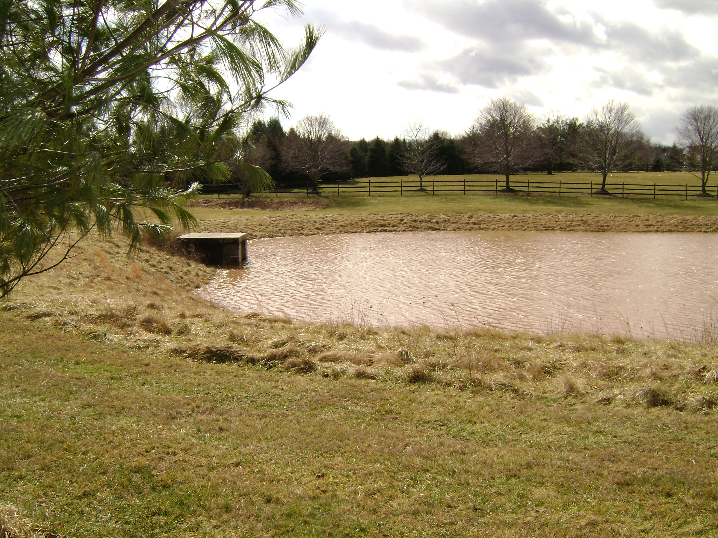
The Neshanic River Watershed has been listed in the New Jersey Integrated Water Quality Monitoring and Assessment Report, which includes the 305(b) Report and 303(d) List, as impaired for phosphorus and total suspended solids (TSS). Stormwater runoff from developed areas is a primary source of these pollutants. Although runoff from many developed sites is managed with detention basins (See Figure 3), these systems are mainly designed to reduce downstream flooding and do little to address water quality. In most cases, detention basins can be retrofitted to enhance their pollutant removal capabilities and achieve water quality improvements.
Figure 3: Detention Basin in TN3a

A survey of stormwater infrastructure in the Neshanic River Watershed was conducted and located a total of 130 detention basins (maps are attached to this document with the locations of every detention basin in the watershed). Approximately 100 of the 130 detention basins are designed strictly for peak flow reductions mitigating downstream flooding impacts. The visual inspection of the basins indicates that the condition of 110 of the detention basins is “good.” This classification of “good” is strictly based upon an aesthetic review of each basin; no water quality, flow control or infiltration rates were collected or evaluated. Many of these detention basins can be altered or retrofitted to improve their ability to remove TSS and phosphorus loads from stormwater runoff and achieve water quality improvements. If these improvements are made correctly, they could improve water quality, as well as reduce maintenance costs for municipalities and homeowner associations.

Detention Basin Retrofit Design Alternatives

The rainfall event used to analyze and design stormwater best management practices (BMPs) for water quality improvements is the “water quality storm” of 1.25 inches of rain over two hours. This storm can be used to compute runoff volumes and peak rates to ensure that stormwater quality BMPs, whether they are based on total runoff volume or peak runoff rate, will provide a standard level of stormwater pollution control. Since approximately 90% of storms in New Jersey are typically smaller than the water quality storm, BMP designs and retrofits that treat these small storms will have a significant impact on improving water quality in the watershed.

1) Low Flow Vegetated Channel

A common design feature for detention basins is a low flow concrete channel that carries runoff from the inlets to the outlet structure of the detention basin. This feature is intended to force water to quickly pass through the basin during small storm events to avoid ponding and maintenance issues. Due to sediment and debris accumulation in these channels and the lack of regular maintenance, these channels frequently tend to clog, causing ponding of water in the channel. The small stagnant ponds become ideal mosquito breeding habitat, thereby creating a problem they originally intended to avoid.

Low flow concrete channels act as an impediment to improving water quality in a detention basin. It is recommended to remove the concrete channel and replace it with a vegetated swale (see attached detail). The swale should have a 0.1% side slope to ensure easy maintenance and a slope not to exceed 3%. The swale should be seeded with native grasses to minimize maintenance. Where possible, replacement soils should be installed with the top 1.5 feet of soil composed of a bioretention soil mix to encourage infiltration (see detail). Below this infiltration media, a 6″ layer of 3/4″ diameter clean stone should be installed. The native vegetation in the swale should be cut once or twice a year.

Dense native vegetation creates friction along the flow path of runoff through the detention basin. This friction slows the water allowing sediment to settle out. Water will be held in the detention basin longer increasing infiltration and allowing the vegetation to take up nutrients carried in stormwater runoff. Finally, native vegetation that is allowed to grow taller will develop a deep root structure allowing a much greater infiltration rate than soil with short turf grass. The channel should be designed to infiltrate and pass water through within 48 hours after a storm to prevent mosquito breeding.

2) Low Flow Rip-Rap Channel

This design is similar to the vegetated channel but instead of vegetation, the channel is filled with rip-rap stone. The channel should not be any wider than 10 feet with the bottom at least three feet above the seasonal-high groundwater elevation. The channel should be designed to hold the runoff volume of the water quality storm from the detention basin’s drainage area. The infiltration rate of the soil where the channel will be installed should be taken into consideration before sizing. The channel will infiltrate any storm equal to or smaller than the water quality storm within 48 hours.

When retrofits are installed, the concrete channel should be completely removed.

3) Native and Low Maintenance Grasses and Vegetation

Detention basins with turf grass provide for minimal infiltration. Turf grass has a shallow root structure that does not open up the soil below the surface allowing water to infiltrate. By introducing native grasses and reducing the frequency of mowing from once a week to once or twice a year (in the winter), native grasses develop a deep root structure. The height of the grass is directly proportional to the depth of the root structure. Limiting mowing and allowing the grass to grow taller will ensure development of a deep root structure. This method reduces maintenance costs due to less mowing and improves water quality through increases in infiltration and subsequent decreases in stormwater discharges to nearby waterways.

Additionally, many basins throughout New Jersey are over-compacted, thereby limiting their infiltration capacity. Although the root structure of native vegetation may increase infiltration rates, some of these over-compacted basins may need to be deep-tilled to loosen up the soil, and soil amendments may need to be added. Promoting infiltration in these basins is important to improve water quality in the watershed.

Location

The location of each detention basin in each subwatershed is shown in the figures presented in Appendix C. The location of the detention basins were collected through a stormwater infrastructure survey. While this survey did review the basins aesthetically, the basins should be reviewed again on a functional scale (infiltration, peak discharges and water quality). Approximately 100 detention basins exist in the watershed that should be evaluated as candidate sites for retrofitting to improve water quality.

Implementation

Municipalities should select detention basins to retrofit, starting with sites that are easiest to retrofit and have the greatest impact on water quality. The Rutgers Cooperative Extension Water Resources Program recommends the basin at the south of Lambert Road near the corner of Lambert Road and Rosemont Ringoes Road in Delaware Township for retrofit. From site visits, it is clear that this detention basin has little effect on improving water quality and can serve as a demonstration in the watershed.

The modifications of the detention basins should take a short amount of time. Although heavy equipment may be needed to remove the concrete channel and install the vegetative channel, precautions should be taken to avoid over-compacting the basin. Deep-tilling may be needed to loosen the soil in areas where heavy equipment is driven. The native grass will be seeded in the basins after the turf grass in the basin has been eliminated with an herbicide. Seed will need to be covered and protected from erosion.

The detention basins must be inspected for excessive debris and sediment accumulation at least four times annually, as well as after every storm exceeding one inch of rainfall. Sediment removal should take place when the basin is thoroughly dry. Disposal of debris, trash, sediment, and other waste material should be done at suitable disposal/recycling sites and in compliance with all applicable local, state, and federal waste regulations (Semple et al., 2004).

Mowing of these newly vegetative basins must be performed on a regular schedule based on specific site conditions (once every six months). Vegetated areas must be inspected at least annually for erosion, scour and unwanted growth, which should be removed with minimum disruption to the planting soil bed and remaining vegetation. When establishing or restoring vegetation, biweekly inspections of vegetation health should be performed during the first growing season or until the vegetation is established. Once established, inspections of vegetation health, density, and diversity should be performed during both the growing and non-growing season at least twice annually. Use of fertilizers, mechanical treatments, pesticides and other means to assure optimum vegetation health must not compromise the intended purpose of the vegetative filter. Vegetation deficiencies should be addressed without the use of fertilizers and pesticides whenever possible. The vegetative detention basin system should be inspected for excess ponding after significant storm events. Corrective measures should be taken when excessive ponding occurs (Semple et al., 2004).

Prioritization

A stormwater infrastructure survey was completed as part of the Watershed Restoration Plan documenting existing detention basins. The survey indicated the type of vegetation, the general condition of the basin, if the outlet structure has a water quality outlet and if it has a low flow concrete channel and an under drain. The table below indicates values used to rate each parameter. The values are added together and the detention basins with the highest value have been given the highest priority. The highest value a detention basin can have is 30 and the lowest value is 5. Any detention basin with a value greater than 25 should be considered a high priority for restoration. Detention basins with values equal to or greater than 9 and equal to or less than 25 should be considered a medium priority for restoration. Any detention basin with a value less than 9 should be considered a low priority for restoration. The prioritization was arrived at by assuming that the following are acceptable: a turf grass basin bottom (4), a condition rating of good (1), a turf or stone low flow channel (2), a cutoff (1), and a water quality outlet (1). These acceptable values for each parameter are based upon input from the project partners obtained during regular project meetings. The numeric ranking of each detention basin is presented in Appendix D.

Detentions basin retrofits will address the following parameters: total suspended solids (TSS), total phosphorus and pathogens. Detention basins have diverse drainage areas that can be a source of all the pollutants of concern. (See priority sheet for ranking in Appendix D).

Detention Basin Bottom Vegetation and Condition of Basin
Condition | 1 | 2 | 3 | 4 | 5 | 6
Basin Bottom | Tree Succession, Wetlands | Grasses Natural | Wetland and Turfgrass | Turf Grass | Weeds | No Vegetation
Condition | Good |  |  |  | Need Repair | Urgent

Low Flow Concrete Channel
Condition | 1 | 2 | 3 | 4 | 5 | 6
Low Flow Channel | Wetland | Turf or Stone |  |  | Concrete | Other
Cutoff | Yes |  |  |  |  | No

Detention Basin Outlet Configuration
Condition | 1 | 2 | 3 | 4 | 5 | 6
Water Quality Outlet | Yes |  |  |  |  | No

*only if soil and percolation tests show little potential for infiltration

Cost

The cost of the detention basin will vary depending on the amount of work that needs to be done to improve the detention. If the detention basin needs to be excavated and replanted the cost would be approximately $2 to $4 per square foot of the detention basin. When a detention basin needs to be re-vegetated the cost to improve the detention basin is $0.25 to $2 per sq. ft. The cost estimates vary because the designs to improve the detention basins have so much flexibility to them. The cost to remove a low flow concrete channel is approximately $100 per linear foot of low flow channel.

Expected Results

Retrofit designs should target infiltration of runoff generated from the water quality storm. Since approximately 90% of all storms in each year in New Jersey come in storms smaller than the water quality storm, this will have a dramatic effect on water quality in the watershed. While it is hard to measure the exact effect, the basins will have many of the same characteristics as a vegetated filter strip. It is difficult to estimate the reductions for each pollutant because many of the functions of the basin will be enhanced by the proposed changes. Targeted reductions in TSS, total phosphorus and total nitrogen are expected to be 90%, 60% and 30%, respectively. Depending on the final design of the detention basin, it will function like a bioretention basin or a wetland. The removal rates for bioretention basins and wetlands are at or above 90% for fecal coliform (Rusciano, 2007 and Karathanasis et al., 2003). Since drainage areas for each basin were not readily available, it is impossible to estimate the total pounds of pollutants removed by retrofitting the detention basins in the Neshanic River Watershed.

Roadside Ditch Design Alternatives

Current Conditions

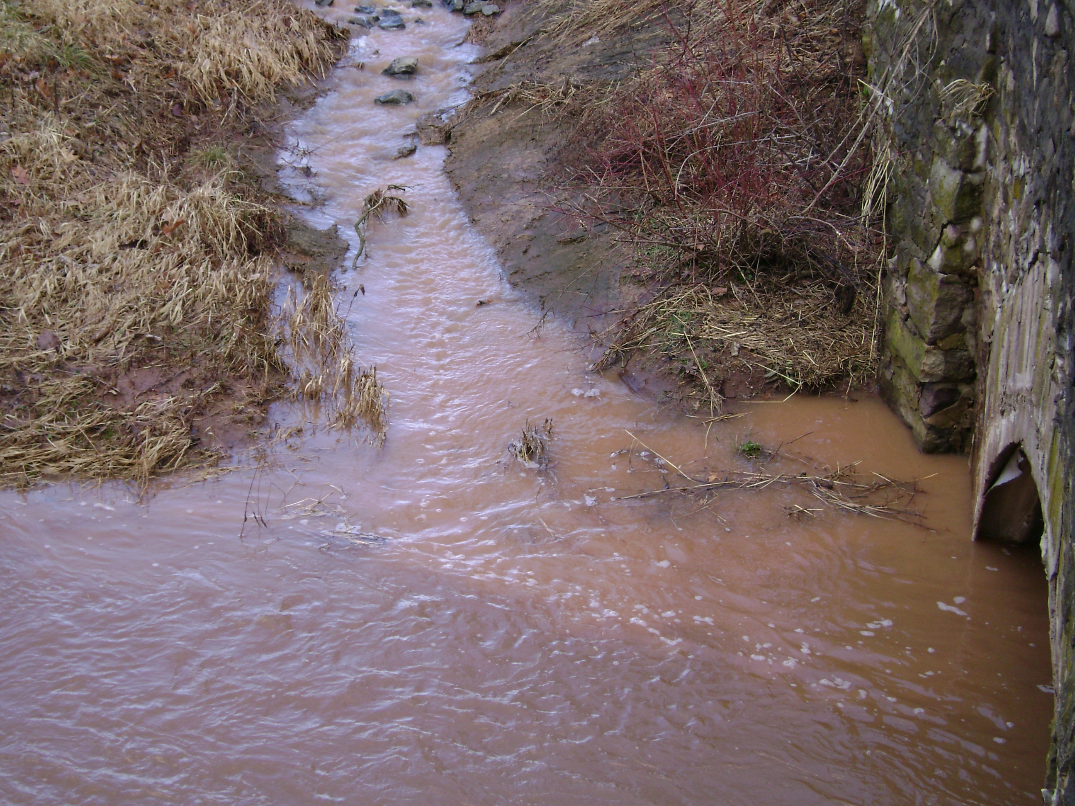
There is a TMDL for fecal coliform in the Neshanic River Watershed, and its streams are impaired for phosphorus and total suspended solids (TSS). It is listed on Sublist 5 of the New Jersey 2004 Integrated Water Quality Monitoring and Assessment Report. Although, the water quality data collected during this project did not show total suspended solids above the Surface Water Quality Standards (SWQS) there is still concern for TSS in the watershed. While researchers were in sub basin TN3a during a storm event, the tributaries were observed to be cloudy and apparently contaminated with TSS. During the site visit it was documented through photographs that sources of TSS could be the drainage ditches along roadways in the watershed (Figure 4). This appears to be a common problem in rural areas throughout the watershed. Sampling data has confirmed the TMDL for fecal coliform and the Sublist 5 listing for phosphorus. Livestock and fertilizer on rural land could travel to the stream in the runoff through the drainage ditches.
Figure 4: Drainage Ditch Contaminating the Stream

The Neshanic River Watershed has sub basins dominated by both urban and rural land uses. Runoff from roadways in rural areas is usually routed by the use of drainage ditches. Roadside ditches do not have design standards unlike more conventional stormwater systems. Ditches are adhoc creations. The ditches appear to be designed not for stormwater management but convenience to the landowner. This approach to ditch design exacerbates water quality issues. In addition, typical ditches are not well maintained and usually consist of bare soil (a source of TSS, see Figure 5).

Without proper design, drainage ditches will continue to be deterrents to water quality. Simple designs, that take advantage of nature’s mechanism for treating stormwater, can have positive effects on water quality and quantity issues in stormwater runoff that it is transported by ditches.

Ditch Design Alternative

Design Objectives

The recommended management strategy is meant to protect the existing drainage ditches from erosion and improve the water quality of runoff traveling through them. The New Jersey Department of Transportation (NJDOT) Roadway Design Manual requires outlet protection of conduits for runoff velocity generated during the 25-year storm (at a minimum) to prevent erosion. Therefore it is recommended that any alteration of designs for a drainage ditch should provide for the capacity of a 25-year storm to prevent erosion in the ditch. The other goal of the strategy is to improve water quality of the runoff entering the ditch. A common method of improving water quality is to reduce the velocity of runoff to allow contaminants it carries to settle out. Designs should work to mimic the flow reductions seen in grassed filter strips for water quality improvement. An additional benefit of reducing velocities is encouraging infiltration of stormwater by retaining runoff in the ditch for more time (another way to improve water quality).

When recommendations are made to improve road side ditches, it is typically planned to widen and plant with a diverse mix of vegetation. Vegetation creates friction to reduce flow and encourage infiltration. The Neshanic River Watershed and especially Delaware Township (where the majority of roadside ditches are located) have a very narrow right of way along the side of the road. Ditches need to be widened when vegetation is added to make maintenance of the ditches easier and more affordable. There is very little space available to widen the ditches in the Neshanic River Watershed due to the limiting size of the right of ways. Instead, this strategy recommends using rip-rap (large stones), gabion baskets and weirs in different ways to control the flow as the vegetation would. Due to the space constrictions in the Neshanic River Watershed, this is seen as the easiest way to transform the roadside ditches from a potential pollution source to a treatment device for stormwater.

1) Strategy 1

Stone-filled gabion baskets are inexpensive and easy to install. The geabion basket is an empty cube made of wire mesh. The mesh is filled with large stone; the stone can provide structural support while the mesh holds the stone in place. Gabion baskets have been used in the past as check dams for swales and other drainage channels. While the baskets are porous, they restrict flow through them. Gabion baskets can be installed periodically in drainage ditches to serve as an obstruction reducing the velocities in the channel and improving water quality. Gabion baskets reduce the velocity of the runoff allowing contaminants to settle out. Reductions in velocity retain runoff in the channel longer allowing more time for stormwater to infiltrate. The reduction in velocity will require the ditches to have a larger storage capacity. While there is little room to widen the ditch it can be deepened to meet the additional storage capacity requirements. Details of the check dam system are provided at the end of this document.

2) Strategy 2

A French drain is an underground trench filled with stone. The trench is a drainage device that creates a path of least resistance for water to flow. This proposed strategy is a French drain exposed to the surface. The basic design for this strategy proposes stone filled channels. The size of the channels filled with stone and portions of the ditch upstream of the exposed French drain need to be designed to account for the additional storage capacity required in the ditch due to the reduction in velocity of the runoff. The front and the end of the French drain needs to have structural support to prevent stone from dispersing up and down stream over time. A gabion basket check dam placed at the front and back of each exposed French drain would provide sufficient support. Essentially, this is a longer check dam. It is useful for locations that require vehicles to cross the ditch on a routine basis (farmers often require this, and it could also be used for driveways).

3) Strategy 3

Gabion baskets provide a basic form of velocity control. They do not have the flexibility of flow control that other devices have such as weirs. A weir is simply a wall with a notch cut out of it. The size and placement of the notch has a strong effect on the amount of flow that the weir will allow through it. The flow is controlled by the shape, elevation and size of the notch and the height of the water behind the notch. The higher the water behind the weir and the larger the shape and size, the higher the flow rate. Weirs have been used for centuries. They can easily be constructed with a concrete footing and cinder blocks. This strategy is interchangeable with Strategy 1. They accomplish the same goals and have the same requires for additional storage capacity. The weir’s advantage over the check dam is that you get greater control over the flow but it will cost more to design and implement than the basket.

The space between the weirs or other flow control mechanisms can be transformed into rain gardens. Rain gardens can make ditches more aesthetically pleasing and can be used as a tool to convince stakeholders to embrace the proposed changes to ditches as many of these changes may not be aesthetically pleasing.

Location

The location of existing roadside ditches are shown in the figures provided in Appendix E. The strategies listed above should be implemented where feasible. If all existing ditches were retrofitted with the recommended strategies in the Neshanic River Watershed it would have an impact on 48.5 acres of roadway and many more acres of surrounding drainage areas.

Implementation

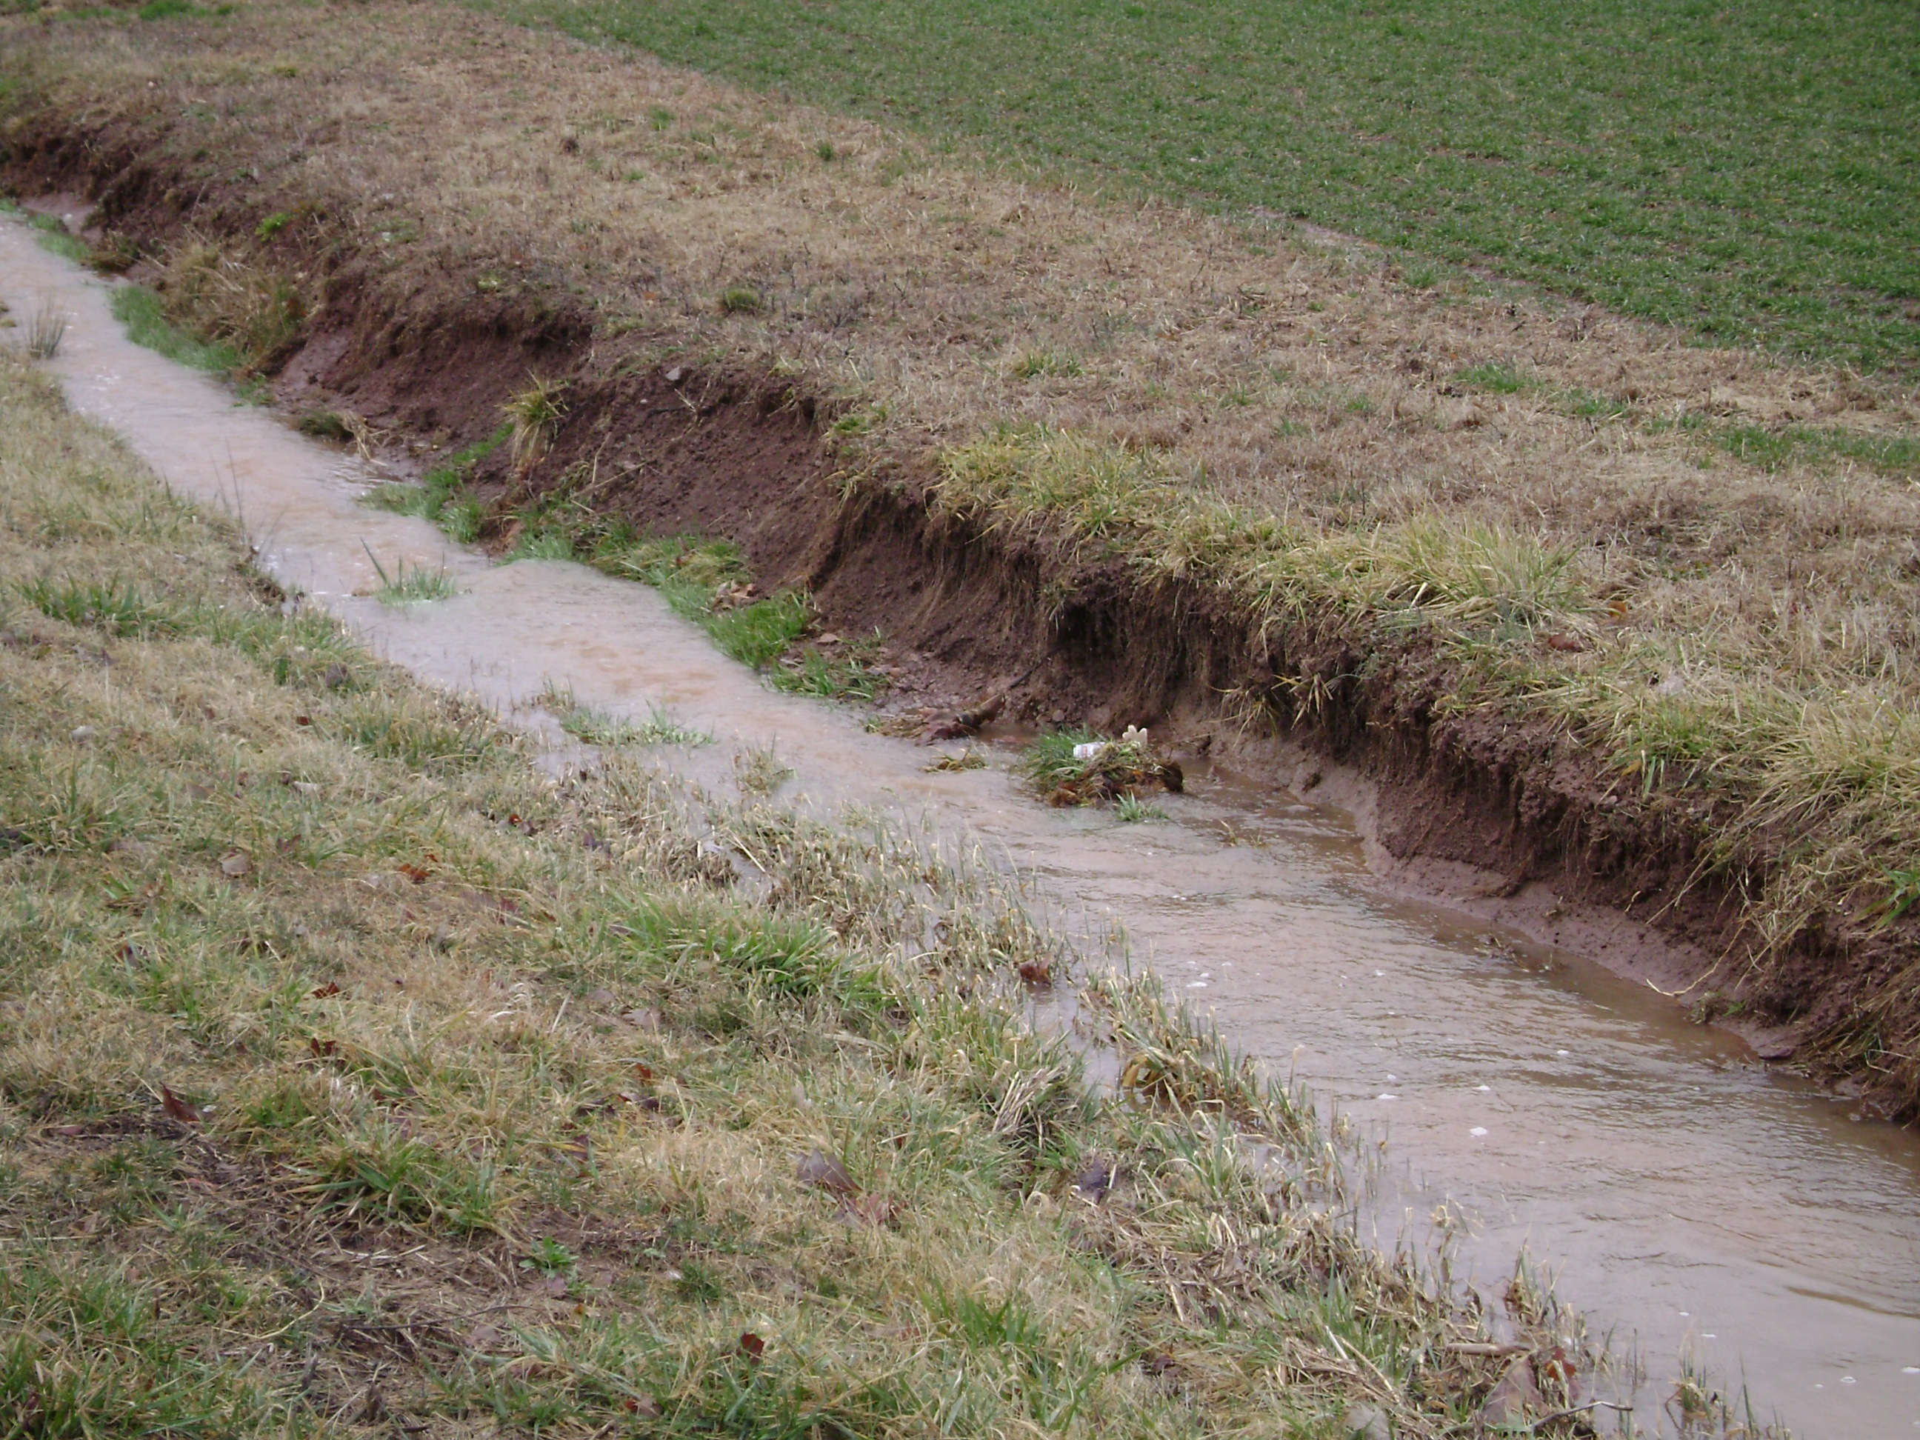
After municipalities identify a roadside to implement one of the recommended strategies, several existing parameters would need to be measured to ensure a successful design. The existing infiltration rate of the soils for the ditch should be tested. The test should be conducted for every 500 ft of ditch length or noticeable change in soil type. A survey should be conducted or existing topography data should be collected to determine the drainage area for the ditch (it may be more than the roadway). While the topography data is being collected, the slope of the ditch should be included. The two limiting parameters for the strategies are the width of the right-of-way and the depth to groundwater. The system cannot exceed the width of the right-of-way and the system should always be located above the seasonal high groundwater elevation (at least two feet).
Figure 5: Existing Drainage Swale

The strategies will involve relatively minor work for implementation. The activities included would be re-shaping the ditch (excavation), installing the flow constriction device (gabion basket check dams, weirs, and/or rip-rap), reseeding any bare soil and following the soil erosion and sediment control protocol to protect bare soil from erosion. If during the construction of the design, over 5,000 square feet of land is disturbed then the project will require a Soil Erosion Sediment Control Permit. The municipality should have a discussion with the NJDOT about its drainage plans. If the design adheres to recommendations there should no problem with the NJDOT. The NJDOT have criteria for drainage of the roads in NJ but they are flexible in the approach as long as it meets the standards.

The drainage system will require inspection every three months (a visual inspection while driving along the system will suffice). The swale should be inspected for standing water, debris, excess sediment, and health of vegetation. While vegetation is not part of the recommended strategies, there should be no bare soil in the ditch; the ditch should retain grass for additional erosion protection and infiltration. The grass in the ditches shall be allowed to grow with debris and excess sediment removed on a routine basis. Excess sediment can be removed by hand with a flat bottomed shovel; dead vegetation should immediately be removed and replaced. Vegetation should appear healthy with no visible bare spots in the system. Clean edges should be maintained between the road and the system with no signs of erosion or litter. Any noted evidence of vehicle compaction should be addressed and standing water remaining after 24 hours is evidence that additional maintenance is needed.

Prioritization

Every drainage ditch and its upstream culvert in the Neshanic River Watershed are documented in the Stormwater Infrastructure Survey. The survey indicates what the ditches are made of and the conditions of the ditch and the condition of the culverts in each ditch. The values from each parameter described in the tables below are summed, and the drainage ditches with the highest value have the highest priority. The highest value a ditch can have is 18, and the lowest value is 3. Any ditch with a value greater than 15 should be considered a high priority for restoration. Ditches with values equal to or greater than 6 and equal to or less than 15 should be considered a medium priority for restoration. Any ditch with a value less than 6 should be considered a low priority for restoration. The prioritization was arrived at by assuming that the following are acceptable: a good ditch rating (1), a stone-type ditch (3), and a formal design for the ditch (1). These acceptable values for each parameter are based upon input from the project partners obtained during regular project meetings. These rankings are presented in Appendix F.

Ditches address the following parameters: TSS, total phosphorus and pathogens.

Ditch
Condition | 1 | 2 | 3 | 4 | 5 | 6
Ditch Rating | Good |  |  |  | Need Repair | Urgent
Type | Wetland | Turf grass, Other Vegetation | Stone | Mixed | Soil | Other
Design | Yes |  |  |  |  | No or unsure

Cost

The cost estimate for the first strategy is based on how many gabion baskets are installed in each ditch. The number of gabion baskets is based on many factors discussed above. The cost to buy the materials and install one gabion basket would be approximately $200. The second strategy includes the use of gabion baskets but also laying stone in narrow ditches. The cost for the material and installation per length of stone would be $400 for the gabion basket on each end of length and $100 per linear foot of stone in between the two gabion baskets. Finally, installation of a weir with a scour hole in place of a gabion basket would cost $400 per weir installation.

Expected Results

The strategies above will turn the ditches into something very similar to stormwater constructed stormwater wetlands. The removal rate for constructed stormwater wetlands is 90% for TSS, 50% for total phosphorus and 30% for nitrogen. According to Karathanasis et al., (2003), the removal rate of wetlands for fecal coliform is 93%.

Assuming that the ditches will treat 90% of the stormwater runoff and assuming the aerial loading coefficients for the 48.5 acres of roadways being treated by these ditches are 2.1, 22 and 200 pounds per acre per year of total phosphorus, total nitrogen, and total suspended solids, respectively, we can calculate the total pounds of total phosphorus, total nitrogen and total suspended solids removed as 46, 288, and 7,857 pounds per year. In reality, the ditches will treat much more area than just the 48.5 acres of roadway. These ditches should be able to treat the land adjacent to the roadways, yielding much larger reductions in pollutant loads.

Vegetated Buffers for Non-Agricultural Developed Lands

Current Conditions

The Neshanic River Watershed has been listed in the New Jersey Integrated Water Quality Monitoring and Assessment Report, which includes the 305(b) Report and 303(d) List, as being impaired for phosphorus and total suspended solids (TSS). Although a significant source of phosphorus and TSS is stormwater runoff from agricultural lands, non-agricultural land uses such as residential, commercial, industrial, barren lands, and park lands can also contribute to the phosphorus and TSS loads entering the stream. Sources of pollutants are typically roadway sediment and lawn fertilizer, as well as soil erosion from unstable areas.

The Neshanic River Watershed was once dominated by agriculture and natural landscapes. Over time, more and more housing developments have been constructed in the Neshanic River Watershed. As the natural landscapes disappear from the Neshanic River Watershed, the protective vegetated buffers surrounding the Neshanic River and its tributaries disappear. Residential neighborhoods, commercial development, and industrial development have been replacing the natural landscapes. These properties usually have turf grass as their dominant form of vegetation. This turf grass can come right up to the shoreline of the stream. Streams need a diverse assemblage of vegetation along the shoreline to provide shade, to establish habitat and to filter stormwater runoff. Streams that run through these properties without any vegetated buffers can be sources of nutrients and TSS within the watershed. The nutrients and bacteria collect on the surface near the shoreline. When a storm event occurs, the stormwater runoff carries the nutrients directly to the stream without being treated by a vegetated buffer.

Vegetated Buffer

A vegetated buffer is an area designed to remove suspended solids and other pollutants, as well as associated pollutants such as hydrocarbons, heavy metals, and nutrients, from stormwater runoff. A vegetated buffer is intended to receive stormwater runoff as sheet flow for maximum pollutant removal. The TSS removal rate for vegetated buffers will depend upon the vegetated cover in the vegetated buffer, but is reported to range from 60 to 80% (Semple et al., 2004). The pollutant removal mechanisms include sedimentation, filtration, adsorption, infiltration, biological uptake, and microbial activity. Vegetated buffers have a removal rate of 30% for phosphorus and nitrogen (Semple et al., 2004). Vegetated buffers that are planted with woody material may also create shade along water bodies that decrease aquatic temperatures, provide a source of detritus and large woody debris for fish and other aquatic organisms, and provide habitat and protective corridors for wildlife. Figure 6 is an example profile of a vegetated buffer.

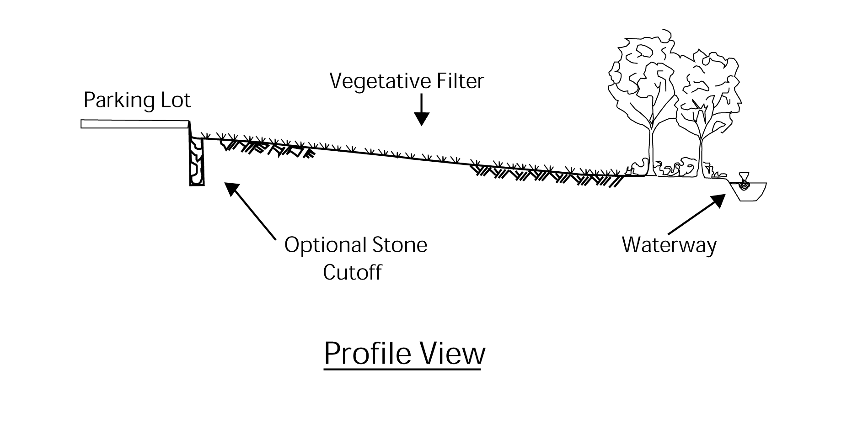

Figure 3: Typical Profile of a Vegetated Buffer (Semple et al,. 2004)

Proposed Location

Attached is a map that shows the location of every potential buffer project along developed but non-agricultural land uses with the Neshanic River Watershed. Any portion of stream or waterbody that is surrounded by non-agricultural developed land and appears to have little or no existing buffer along the stream is considered a potential site for a buffer project. This project has approximately 27,603 feet (5.2 miles) of potential vegetated buffer sites.

Implementing this Project

This project will be a product of the collaborative effort of the Rutgers Cooperative Extension Water Resources Program and the North Jersey Resource, Conservation and Development Council, Inc. (North Jersey RC&D). The two programs will collaborate to create a program that will conduct outreach to local stakeholders to install vegetated buffers, determine appropriate sites, design buffers, oversee the implementation, and periodically inspect each buffer.

First, both programs will use the potential vegetated buffer location map attached at the end of this document. The map was created by using land use data from the New Jersey Department of Environmental Protection (NJDEP) and reviewing aerials throughout the entire watershed to determine all the locations where vegetated buffers can be installed on non-agricultural developed land use. After the location map has been reviewed, both programs will begin its outreach to the local stakeholders. The group will focus on the stakeholders who own land on property that has been targeted for a vegetated buffer. This project will be publicized, and the public will be encouraged to present new potential locations for vegetated buffers not originally outlined in the location map. Each new location that is presented to the group will be evaluated via geographic information system (GIS) information and a site visit. It is up to the group to determine if the site is appropriate and should have a vegetated buffer installed on it.

Once the group has collected enough agreements from property owners to install vegetated buffers on their property, the Water Resources Program will design each of the buffers. Next, the Water Resources Program and North Jersey RC&D will solicit bids from local contractors to install the vegetated buffers. The North Jersey RC&D and the Water Resources Program will oversee the construction of each of the vegetated buffers. Periodically, a staff member from the Water Resources Program or the North Jersey RC&D will visit each vegetated buffer and inspect it to determine if it is being maintained properly and if it is functioning as intended. If a problem does arise, the Water Resources Program and North Jersey RC&D will be informed immediately and actions will be taken to correct the situation.

Maintenance

Vegetated buffers are expected to trap debris and sediment therefore they must be inspected for clogging and excessive debris and sediment accumulation at least four times annually and after every storm exceeding one (1) inch of rainfall. Sediment removal should take place when the vegetated buffer is thoroughly dry. Disposal of debris and trash should be done only at suitable disposal/recycling sites and must comply with all applicable local, state, and federal waste regulations (Semple et al.,2004).

Mowing of vegetated buffers must be performed on a regular schedule based on specific site conditions (typically once every six months is the minimum). Grass should be mowed at least once a month during the growing season. Vegetated areas must be inspected at least annually for erosion and scour. Vegetated areas should also be inspected at least annually for unwanted growth, which should be removed with minimum disruption to the planting soil bed and remaining vegetation. When establishing or restoring vegetation, biweekly inspections of vegetation health should be performed during the first growing season or until the vegetation is established. Once established, inspections of vegetation health, density, and diversity should be performed during both the growing and non-growing season at least twice annually. All use of fertilizers, mechanical treatments, pesticides and other means to assure optimum vegetation health must not compromise the intended purpose of the vegetated buffer. All vegetation deficiencies should be addressed without the use of fertilizers and pesticides whenever possible. All areas of the vegetated buffer should be inspected for excess ponding after significant storm events. Corrective measures should be taken when excessive ponding occurs (Semple et al., 2004).

Cost

The cost of each vegetated buffer will vary with the difficulty and complexity of each design and size of the project. Vegetated buffers that consist of warm season grasses will be considerably less expensive than designs that require larger vegetation in a more complex design. The designs will incorporate ideas given to the Water Resources Program by the property owners, but each design will find the balance between the design for a vegetated buffer and the property owner’s design. The designs will strive to be as inexpensive as possible.

Prioritization

The subwatershed ranking for greatest need of vegetated buffers on non-agricultural developed land uses is based on the phosphorus ranking (See priority sheet for ranking).

Municipalities can partner with local environmental organizations, environmental commissions and other community organizations to reach out to home and business owners to identify target neighborhoods and business willing to vegetated buffer installed on their property and maintain them for the town.

Expected Results

Following the design standards outlined in this document, the vegetated buffers installed should remove 70% of the TSS in the runoff that it filters throughout the year and 30% of the nitrogen and phosphorus in the runoff. There is no removal rate for bacteria from a vegetated buffer, but it is fair to assume that the bacteria act as particles much like sediment, and the removal rate should be similar because the same mechanism expected to reduce TSS will reduce bacteria.

References
Rusciano, G.M. and C.C. Obropta. 2007. Bioretention Column Study: Fecal Coliform and Total Suspended Solids Reductions. Transactions of the ASABE 50(4): 1261-1269.

Karathanasis, A. D., C. L. Potter, and M. S. Coyne. 2003. Vegetation Effects on Fecal Bacteria, BOD, and Suspended Solid Removal in Constructed Wetlands Treating Domestic Wastewater. Ecological Engineering 20.2: 157-69.

Semple, Alice; Blick, Sandra; Kelly, Fred and Skupien, Joseph. 2004. New Jersey Stormwater Best Management Practices Manual. New Jersey Department of Environmental Protection, Trenton.

APPENDIX A

Residential Development Suitable for Rain Gardens
INSERT FIGURES HERE

APPENDIX B

Summary Tables of Residential Sites Suitable for Rain Gardens

Potential Rain Garden Sites in SN1 | Area of Potential Neighborhoods  (acres) | Number of Houses within Site
SN1_001 | 192.1 | 91
SN1_002 | 45.0 | 23
SN1_003 | 76.2 | 20
SN1_004 | 107.6 | 54
SN1_005 | 33.5 | 19
SN1_006 | 113.2 | 58
SN1_007 | 154.7 | 63
SN1_008 | 240.9 | 59
SN1_009 | 161.0 | 135
SN1_010 | 21.8 | 19
Number of Houses not in Neighborhoods | NA | 116
TOTAL: | 1,146 | 657
Potential Rain Garden Sites in TN3a | Area of Potential Neighborhoods  (acres | Number of Houses within Site
TN3a_002 | 69.4 | 30
TN3a_001 | 84.2 | 13
Number of Houses not in Neighborhoods | NA | 352
TOTAL: | 154 | 405
Potential Rain Garden Sites in FN1 | Area of Potential Neighborhoods  (acres | Number of Houses within Site
FN1_001 | 21.1 | 16
FN1_002 | 30.7 | 25
FN1_003 | 53.5 | 18
FN1_004 | 35.6 | 16
FN1_005 | 38.5 | 22
FN1_006 | 40.7 | 132
FN1_007 | 31.2 | 133
FN1_008 | 150.9 | 91
FN1_009 | 21.3 | 19
FN1_010 | 7.3 | 42
FN1_011 | 8.3 | 16
FN1_012 | 97.9 | 59
FN1_013 | 36.5 | 10
Number of Houses not in Neighborhoods | NA | 154
TOTAL: | 573 | 753
Potential Rain Garden Sites in UNT2 | Area of Potential Neighborhoods  (acres) | Number of Houses within Site
UNT2_001 | 286.4 | 146
UNT2_002 | 78.6 | 50
UNT2_003 | 40.1 | 27
UNT2_004 | 161.7 | 85
Number of Houses not in Neighborhoods | NA | 15
TOTAL: | 567 | 323

Potential Rain Garden Sites in UNT1 | Area of Potential Neighborhoods  (acres) | Number of Houses within Site
UNT1_001 | 40.5 | 30
UNT1_002 | 204.5 | 135
UNT1_003 | 101.5 | 54
UNT1_004 | 39.8 | 21
UNT1_006 | 30.1 | 17
UNT1_005 | 16.2 | 13
UNT1_008 | 58.1 | 42
UNT1_009 | 11.4 | 8
UNT1_007 | 35.1 | 29
UNT_010 | 29.9 | 20
Number of Houses not in Neighborhoods | NA | 76
TOTAL: | 567 | 445
Potential Rain Garden Sites in N1 | Area of Potential Neighborhoods  (acres) | Number of Houses within Site
N1_001 | 83.9 | 47
N1_002 | 37.0 | 69
N1_003 | 15.4 | 54
N1_004 | 63.3 | 156
N1_005 | 165.5 | 343
N1_006 | 167.1 | 108
N1_008 | 97.3 | 58
N1_007 | 32.7 | 16
N1_009 | 20.8 | 11
Number of Houses not in Neighborhoods | NA | 53
TOTAL: | 683 | 915
Potential Rain Garden Sites in TN3 | Area of Potential Neighborhoods  (acres) | Number of Houses within Site
TN3_001 | 30.3 | 20
TN3_002 | 26.5 | 11
TN3_003 | 16.6 | 10
TN3_004 | 23.8 | 12
Number of Houses not in Neighborhoods | NA | 4
TOTAL: | 97 | 57

APPENDIX C

Detention Basin Locations within each Subwatershed
INSERT FIGURES HERE

APPENDIX D

Prioritization of Detention Basins by Subwatershed

N1 |  |  | SN1 |  |  | TN3
Rank | Priority | BASIN_ID | Rank | Priority | BASIN_ID | Rank | Priority | BASIN_ID
1 | 28 HP | MDB-0036 | 1 | 24 MP | MDB-0046 | 1 | 24 MP | MDB-0153
2 | 28 HP | MDB-0037 | 2 | 22 MP | MDB-0070 | 2 | 22 MP | MDB-0154
3 | 26 HP | MDB-0136 | 3 | 22 MP | MDB-0054 | 3 | 22 MP | MDB-0209
4 | 24 MP | MDB-0137 | 4 | 22 MP | MDB-0071 | 4 | 17 MP | MDB-0252
5 | 24 MP | MDB-0047 | 5 | 22 MP | MDB-0092 | 5 | 17 MP | MDB-0016
6 | 22 MP | MDB-0145 | 6 | 22 MP | MDB-0093 | 6 | 17 MP | MDB-0060
7 | 22 MP | MDB-0150 | 7 | 22 MP | MDB-0095 | 7 | 14 MP | MDB-0139
8 | 22 MP | MDB-0151 | 8 | 22 MP | MDB-0255 | 8 | 10 MP | MDB-0251
9 | 22 MP | MDB-0222 | 9 | 20 MP | MDB-0061
10 | 21 MP | MDB-0013 | 10 | 19 MP | MDB-0256
11 | 19 MP | MDB-0014 | 11 | 17 MP | MDB-0074
12 | 19 MP | MDB-0217 | 12 | 17 MP | MDB-0075
13 | 18 MP | MDB-0138 | 13 | 17 MP | MDB-0098
14 | 17 MP | MDB-0149 | 14 | 17 MP | MDB-0156
15 | 17 MP | MDB-0189 | 15 | 17 MP | MDB-0253
16 | 17 MP | MDB-0215 | 16 | 17 MP | MDB-0254
17 | 17 MP | MDB-0224 | 17 | 17 MP | MDB-0049
18 | 17 MP | MDB-0250 | 18 | 17 MP | MDB-0069
19 | 17 MP | MDB-0012 | 19 | 17 MP | MDB-0077
20 | 14 MP | MDB-0259 | 20 | 17 MP | MDB-0078
21 | 13 MP | MDB-0059 | 21 | 17 MP | MDB-0081
22 | 11 MP | MDB-0218 | 22 | 17 MP | MDB-0094
23 | 11 MP | MDB-0258 | 23 | 17 MP | MDB-0155
24 | 9 MP | MDB-0246 | 24 | 17 MP | MDB-0239
25 | 6 LP | MDB-0260 | 25 | 15 MP | MDB-0101
26 | 5 LP | MDB-0131 | 26 | 15 MP | MDB-0080
 |  |  | 27 | 14 MP | MDB-0203
 |  |  | 28 | 13 MP | MDB-0115
 |  |  | 29 | 13 MP | MDB-0210
 |  |  | 30 | 12 MP | MDB-0082
 |  |  | 31 | 12 MP | MDB-0242
 |  |  | 32 | 10 MP | MDB-0240
 |  |  | 33 | 8 LP | MDB-0159
 |  |  | 34 | 5 LP | MDB-0157

HP = High Priority; MP = Medium Priority; LP = Low Priority

TN3a |  |  | FN1 |  |  | UNT1
Rank | Priority | BASIN_ID | Rank | Priority | BASIN_ID | Rank | Priority | BASIN_ID
1 | 22 MP | MDB-0035 | 1 | 28 HP | MDB-0143 | 1 | 22 MP | MDB-0072
2 | 19 MP | MDB-0043 | 2 | 22 MP | MDB-0231 | 2 | 22 MP | MDB-0086
3 | 19 MP | MDB-0125 | 3 | 22 MP | MDB-0229 | 3 | 22 MP | MDB-0087
4 | 17 MP | MDB-0045 | 4 | 22 MP | MDB-0110 | 4 | 22 MP | MDB-0089
5 | 14 MP | MDB-0241 | 5 | 22 MP | MDB-0064 | 5 | 22 MP | MDB-0091
6 | 8 LP | MDB-0208 | 6 | 22 MP | MDB-0226 | 6 | 19 MP | MDB-0135
 |  |  | 7 | 22 MP | MDB-0121 | 7 | 19 MP | MDB-0062
 |  |  | 8 | 22 MP | MDB-0118 | 8 | 19 MP | MDB-0084
 |  |  | 9 | 22 MP | MDB-0112 | 9 | 19 MP | MDB-0090
 |  |  | 10 | 22 MP | MDB-0111 | 10 | 18 MP | MDB-0128
 |  |  | 11 | 22 MP | MDB-0055 | 11 | 17 MP | MDB-0133
 |  |  | 12 | 22 MP | MDB-0146 | 12 | 17 MP | MDB-0134
 |  |  | 13 | 21 MP | MDB-0160 | 13 | 11 MP | MDB-0129
 |  |  | 14 | 20 MP | MDB-0113 | 14 | 6 LP | MDB-0130
 |  |  | 15 | 19 MP | MDB-0225
 |  |  | 16 | 19 MP | MDB-0148
 |  |  | 17 | 18 MP | MDB-0142
 |  |  | 18 | 17 MP | MDB-0257
 |  |  | 19 | 17 MP | MDB-0230
 |  |  | 20 | 17 MP | MDB-0227
 |  |  | 21 | 17 MP | MDB-0120
 |  |  | 22 | 17 MP | MDB-0116
 |  |  | 23 | 17 MP | MDB-0108
 |  |  | 24 | 17 MP | MDB-0106
 |  |  | 25 | 17 MP | MDB-0063
 |  |  | 26 | 17 MP | MDB-0119
 |  |  | 27 | 17 MP | MDB-0220
 |  |  | 28 | 17 MP | MDB-0117
 |  |  | 29 | 17 MP | MDB-0107
 |  |  | 30 | 17 MP | MDB-0056
 |  |  | 31 | 15 MP | MDB-0127
 |  |  | 32 | 15 MP | MDB-0109
 |  |  | 33 | 14 MP | MDB-0244
 |  |  | 34 | 12 MP | MDB-0228
 |  |  | 35 | 11 MP | MDB-0243
 |  |  | 36 | 11 MP | MDB-0223
 |  |  | 37 | 11 MP | MDB-0141
 |  |  | 38 | 10 MP | MDB-0144
 |  |  | 39 | 9 MP | MDB-0248
 |  |  | 40 | 9 MP | MDB-0219
 |  |  | 41 | 8 LP | MDB-0053
 |  |  | 42 | 8 LP | MDB-0221

HP = High Priority; MP = Medium Priority; LP = Low Priority

UNT2 |  |  | N2
Rank | Priority | BASIN_ID | Rank | Priority | BASIN_ID
1 | 25 MP | MDB-0039 | 1 | 17 MP | MDB-0011
2 | 22 MP | MDB-0044 | 2 | 11 MP | MDB-0245
3 | 22 MP | MDB-0065
4 | 22 MP | MDB-0066
5 | 22 MP | MDB-0068
6 | 22 MP | MDB-0009
7 | 22 MP | MDB-0067
8 | 22 MP | MDB-0158
9 | 17 MP | MDB-0050
10 | 17 MP | MDB-0247
11 | 17 MP | MDB-0010
12 | 17 MP | MDB-0051
13 | 17 MP | MDB-0052
14 | 17 MP | MDB-0008
15 | 13 MP | MDB-0216
16 | 8 LP | MDB-0140

HP = High Priority; MP = Medium Priority; LP = Low Priority

APPENDIX E

Locations of Existing Ditches within each Subwatershed
(Please note: The figures in this appendix were intended to be plotted on 24" x 36" sheets)
INSERT FIGURES HERE

APPENDIX F

Prioritization of Ditches by Subwatershed

N1 |  |  | N1 (cont'd)
Rank | Score | ID | Rank | Score | ID
1 | 17 HP | SD-382 | 28 | 13 MP | SD-189
2 | 17 HP | SD-389 | 29 | 13 MP | SD-190
3 | 16 HP | SD-187 | 30 | 13 MP | SD-371
4 | 16 HP | SD-373 | 31 | 13 MP | SD-372
5 | 16 HP | SD-375 | 32 | 13 MP | SD-374
6 | 16 HP | SD-376 | 33 | 13 MP | SD-1196
7 | 16 HP | SD-377 | 34 | 13 MP | SD-1198
8 | 16 HP | SD-378 | 35 | 13 MP | SD-1201
9 | 16 HP | SD-379 | 36 | 13 MP | SD-1203
10 | 16 HP | SD-380 | 37 | 12 MP | SD-860
11 | 16 HP | SD-381 | 38 | 9 MP | SD-183
12 | 16 HP | SD-383 | 39 | 9 MP | SD-185
13 | 16 HP | SD-384 | 40 | 9 MP | SD-186
14 | 16 HP | SD-385 | 41 | 9 MP | SD-447
15 | 16 HP | SD-386 | 42 | 9 MP | SD-830
16 | 16 HP | SD-387 | 43 | 9 MP | SD-832
17 | 16 HP | SD-388 | 44 | 9 MP | SD-1132
18 | 16 HP | SD-839 | 45 | 9 MP | SD-1200
19 | 16 HP | SD-840 | 46 | 5 LP | SD-829
20 | 16 HP | SD-900 | 47 | 5 LP | SD-919
21 | 15 MP | SD-184 | 48 | 5 LP | SD-1210
22 | 15 MP | SD-188 | 49 | 4 LP | SD-831
23 | 15 MP | SD-191 | 50 | 4 LP | SD-838
24 | 15 MP | SD-370 | 51 | 4 LP | SD-1199
25 | 15 MP | SD-1197 | 52 | 4 LP | SD-1202
26 | 14 MP | SD-920 | 53 | 4 LP | SD-1209
27 | 14 MP | SD-921

HP = High Priority; MP = Medium Priority; LP = Low Priority

SN1 |  |  | SN1 (cont'd)
Rank | Score | ID | Rank | Score | ID
1 | 18 HP | SD-361 | 41 | 15 MP | SD-456
2 | 17 HP | SD-134 | 42 | 15 MP | SD-457
3 | 17 HP | SD-211 | 43 | 15 MP | SD-458
4 | 16 HP | SD-125 | 44 | 15 MP | SD-459
5 | 16 HP | SD-133 | 45 | 15 MP | SD-467
6 | 16 HP | SD-217 | 46 | 15 MP | SD-468
7 | 16 HP | SD-220 | 47 | 15 MP | SD-828
8 | 16 HP | SD-221 | 48 | 15 MP | SD-971
9 | 16 HP | SD-224 | 49 | 15 MP | SD-973
10 | 16 HP | SD-225 | 50 | 15 MP | SD-975
11 | 16 HP | SD-227 | 51 | 15 MP | SD-1026
12 | 16 HP | SD-245 | 52 | 15 MP | SD-1213
13 | 16 HP | SD-246 | 53 | 15 MP | SD-1218
14 | 16 HP | SD-357 | 54 | 15 MP | SD-1219
15 | 16 HP | SD-358 | 55 | 15 MP | SD-1220
16 | 16 HP | SD-360 | 56 | 15 MP | SD-1221
17 | 16 HP | SD-362 | 57 | 15 MP | SD-1222
18 | 16 HP | SD-365 | 58 | 15 MP | SD-1253
19 | 16 HP | SD-366 | 59 | 15 MP | SD-1254
20 | 16 HP | SD-407 | 60 | 15 MP | SD-1257
21 | 16 HP | SD-463 | 61 | 15 MP | SD-1265
22 | 16 HP | SD-464 | 62 | 15 MP | SD-1266
23 | 16 HP | SD-465 | 63 | 14 MP | SD-229
24 | 16 HP | SD-965 | 64 | 14 MP | SD-232
25 | 16 HP | SD-1214 | 65 | 14 MP | SD-239
26 | 15 MP | SD-128 | 66 | 14 MP | SD-296
27 | 15 MP | SD-129 | 67 | 14 MP | SD-297
28 | 15 MP | SD-135 | 68 | 14 MP | SD-298
29 | 15 MP | SD-202 | 69 | 14 MP | SD-299
30 | 15 MP | SD-214 | 70 | 14 MP | SD-302
31 | 15 MP | SD-215 | 71 | 14 MP | SD-363
32 | 15 MP | SD-218 | 72 | 14 MP | SD-364
33 | 15 MP | SD-219 | 73 | 13 MP | SD-197
34 | 15 MP | SD-226 | 74 | 13 MP | SD-198
35 | 15 MP | SD-244 | 75 | 13 MP | SD-199
36 | 15 MP | SD-247 | 76 | 13 MP | SD-200
37 | 15 MP | SD-250 | 77 | 13 MP | SD-201
38 | 15 MP | SD-308 | 78 | 13 MP | SD-204
39 | 15 MP | SD-309 | 79 | 13 MP | SD-205
40 | 15 MP | SD-455 | 80 | 13 MP | SD-206

HP = High Priority; MP = Medium Priority; LP = Low Priority

SN1 (cont'd) |  |  | SN1 (cont'd)
Rank | Score | ID | Rank | Score | ID
81 | 13 MP | SD-207 | 121 | 13 MP | SD-1086
82 | 13 MP | SD-208 | 122 | 13 MP | SD-1089
83 | 13 MP | SD-209 | 123 | 13 MP | SD-1090
84 | 13 MP | SD-210 | 124 | 13 MP | SD-1217
85 | 13 MP | SD-212 | 125 | 13 MP | SD-1226
86 | 13 MP | SD-213 | 126 | 13 MP | SD-1227
87 | 13 MP | SD-222 | 127 | 13 MP | SD-1279
88 | 13 MP | SD-223 | 128 | 13 MP | SD-1280
89 | 13 MP | SD-228 | 129 | 13 MP | SD-1281
90 | 13 MP | SD-230 | 130 | 12 MP | SD-1170
91 | 13 MP | SD-231 | 131 | 12 MP | SD-1255
92 | 13 MP | SD-233 | 132 | 12 MP | SD-1256
93 | 13 MP | SD-238 | 133 | 12 MP | SD-1264
94 | 13 MP | SD-243 | 134 | 11 MP | SD-1282
95 | 13 MP | SD-248 | 135 | 9 MP | SD-130
96 | 13 MP | SD-249 | 136 | 9 MP | SD-355
97 | 13 MP | SD-251 | 137 | 9 MP | SD-367
98 | 13 MP | SD-252 | 138 | 9 MP | SD-368
99 | 13 MP | SD-300 | 139 | 9 MP | SD-452
100 | 13 MP | SD-301 | 140 | 9 MP | SD-453
101 | 13 MP | SD-303 | 141 | 9 MP | SD-454
102 | 13 MP | SD-305 | 142 | 9 MP | SD-460
103 | 13 MP | SD-306 | 143 | 9 MP | SD-462
104 | 13 MP | SD-307 | 144 | 9 MP | SD-466
105 | 13 MP | SD-310 | 145 | 9 MP | SD-967
106 | 13 MP | SD-356 | 146 | 9 MP | SD-972
107 | 13 MP | SD-359 | 147 | 9 MP | SD-1087
108 | 13 MP | SD-391 | 148 | 9 MP | SD-1088
109 | 13 MP | SD-450 | 149 | 9 MP | SD-1228
110 | 13 MP | SD-451 | 150 | 9 MP | SD-1251
111 | 13 MP | SD-461 | 151 | 8 MP | SD-1271
112 | 13 MP | SD-469 | 152 | 4 LP | SD-216
113 | 13 MP | SD-961 | 153 | 4 LP | SD-304
114 | 13 MP | SD-963 | 154 | 3 LP | SD-1269
115 | 13 MP | SD-964
116 | 13 MP | SD-966
117 | 13 MP | SD-968
118 | 13 MP | SD-969
119 | 13 MP | SD-970
120 | 13 MP | SD-974

HP = High Priority; MP = Medium Priority; LP = Low Priority

TN3 |  |  | TN3a |  |  | TN3a (cont'd)
Rank | Score | ID | Rank | Score | ID | Rank | Score | ID
1 | 13 MP | SD-192 | 1 | 18 HP | SD-527 | 41 | 16 HP | SD-604
2 | 13 MP | SD-234 | 2 | 18 HP | SD-588 | 42 | 1 HP6 | SD-617
3 | 13 MP | SD-235 | 3 | 18 HP | SD-612 | 43 | 16 HP | SD-646
4 | 9 MP | SD-236 | 4 | 18 HP | SD-618 | 44 | 16 HP | SD-649
5 | 9 MP | SD-237 | 5 | 17 HP | SD-525 | 45 | 16 HP | SD-651
6 | 8 MP | SD-861 | 6 | 17 HP | SD-583 | 46 | 16 HP | SD-664
 |  |  | 7 | 17 HP | SD-596 | 47 | 16 HP | SD-666
 |  |  | 8 | 17 HP | SD-679 | 48 | 16 HP | SD-681
 |  |  | 9 | 17 HP | SD-768 | 49 | 16 HP | SD-686
 |  |  | 10 | 17 HP | SD-942 | 50 | 16 HP | SD-702
 |  |  | 11 | 17 HP | SD-1273 | 51 | 16 HP | SD-723
 |  |  | 12 | 16 HP | SD-28 | 52 | 16 HP | SD-778
 |  |  | 13 | 16 HP | SD-32 | 53 | 16 HP | SD-935
 |  |  | 14 | 16 HP | SD-176 | 54 | 16 HP | SD-951
 |  |  | 15 | 16 HP | SD-177 | 55 | 16 HP | SD-953
 |  |  | 16 | 16 HP | SD-180 | 56 | 16 HP | SD-956
 |  |  | 17 | 16 HP | SD-195 | 57 | 16 HP | SD-960
 |  |  | 18 | 16 HP | SD-258 | 58 | 16 HP | SD-1120
 |  |  | 19 | 16 HP | SD-260 | 59 | 16 HP | SD-1272
 |  |  | 20 | 16 HP | SD-269 | 60 | 15 MP | SD-11
 |  |  | 21 | 16 HP | SD-275 | 61 | 15 MP | SD-33
 |  |  | 22 | 16 HP | SD-277 | 62 | 15 MP | SD-124
 |  |  | 23 | 16 HP | SD-294 | 63 | 15 MP | SD-175
 |  |  | 24 | 16 HP | SD-295 | 64 | 15 MP | SD-196
 |  |  | 25 | 16 HP | SD-339 | 65 | 15 MP | SD-240
 |  |  | 26 | 16 HP | SD-341 | 66 | 15 MP | SD-241
 |  |  | 27 | 16 HP | SD-404 | 67 | 15 MP | SD-261
 |  |  | 28 | 16 HP | SD-497 | 68 | 15 MP | SD-262
 |  |  | 29 | 16 HP | SD-499 | 69 | 15 MP | SD-263
 |  |  | 30 | 16 HP | SD-501 | 70 | 15 MP | SD-264
 |  |  | 31 | 16 HP | SD-503 | 71 | 15 MP | SD-268
 |  |  | 32 | 16 HP | SD-504 | 72 | 15 MP | SD-270
 |  |  | 33 | 16 HP | SD-506 | 73 | 15 MP | SD-271
 |  |  | 34 | 16 HP | SD-507 | 74 | 15 MP | SD-272
 |  |  | 35 | 16 HP | SD-536 | 75 | 15 MP | SD-274
 |  |  | 36 | 16 HP | SD-537 | 76 | 15 MP | SD-276
 |  |  | 37 | 16 HP | SD-566 | 77 | 15 MP | SD-291
 |  |  | 38 | 16 HP | SD-575 | 78 | 15 MP | SD-293
 |  |  | 39 | 16 HP | SD-585 | 79 | 15 MP | SD-340
 |  |  | 40 | 16 HP | SD-592 | 80 | 15 MP | SD-344

HP = High Priority; MP = Medium Priority; LP = Low Priority

TN3a (cont'd) |  |  | TN3a (cont'd) |  |  | TN3a (cont'd)
Rank | Score | ID | Rank | Score | ID | Rank | Score | ID
81 | 15 MP | SD-346 | 121 | 15 MP | SD-547 | 161 | 15 MP | SD-718
82 | 15 MP | SD-349 | 122 | 15 MP | SD-548 | 162 | 15 MP | SD-735
83 | 15 MP | SD-350 | 123 | 15 MP | SD-552 | 163 | 15 MP | SD-771
84 | 15 MP | SD-408 | 124 | 15 MP | SD-565 | 164 | 15 MP | SD-777
85 | 15 MP | SD-410 | 125 | 15 MP | SD-569 | 165 | 15 MP | SD-868
86 | 15 MP | SD-411 | 126 | 15 MP | SD-572 | 166 | 15 MP | SD-915
87 | 15 MP | SD-412 | 127 | 15 MP | SD-577 | 167 | 15 MP | SD-936
88 | 15 MP | SD-416 | 128 | 15 MP | SD-579 | 168 | 15 MP | SD-938
89 | 15 MP | SD-432 | 129 | 15 MP | SD-584 | 169 | 15 MP | SD-941
90 | 15 MP | SD-433 | 130 | 15 MP | SD-591 | 170 | 15 MP | SD-943
91 | 15 MP | SD-434 | 131 | 15 MP | SD-593 | 171 | 15 MP | SD-947
92 | 15 MP | SD-435 | 132 | 15 MP | SD-597 | 172 | 15 MP | SD-987
93 | 15 MP | SD-438 | 133 | 15 MP | SD-601 | 173 | 15 MP | SD-994
94 | 15 MP | SD-441 | 134 | 15 MP | SD-603 | 174 | 15 MP | SD-1020
95 | 15 MP | SD-442 | 135 | 15 MP | SD-607 | 175 | 15 MP | SD-1021
96 | 15 MP | SD-443 | 136 | 15 MP | SD-608 | 176 | 15 MP | SD-1121
97 | 15 MP | SD-445 | 137 | 15 MP | SD-631 | 177 | 15 MP | SD-1124
98 | 15 MP | SD-498 | 138 | 15 MP | SD-634 | 178 | 15 MP | SD-1125
99 | 15 MP | SD-500 | 139 | 15 MP | SD-635 | 179 | 15 MP | SD-1128
100 | 15 MP | SD-509 | 140 | 15 MP | SD-636 | 180 | 15 MP | SD-1129
101 | 15 MP | SD-512 | 141 | 15 MP | SD-637 | 181 | 15 MP | SD-1276
102 | 15 MP | SD-513 | 142 | 15 MP | SD-638 | 182 | 15 MP | SD-1277
103 | 15 MP | SD-515 | 143 | 15 MP | SD-640 | 183 | 15 MP | SD-1278
104 | 15 MP | SD-516 | 144 | 15 MP | SD-641 | 184 | 14 MP | SD-7
105 | 15 MP | SD-517 | 145 | 15 MP | SD-643 | 185 | 14 MP | SD-10
106 | 15 MP | SD-519 | 146 | 15 MP | SD-644 | 186 | 14 MP | SD-30
107 | 15 MP | SD-522 | 147 | 15 MP | SD-657 | 187 | 14 MP | SD-31
108 | 15 MP | SD-523 | 148 | 15 MP | SD-658 | 188 | 14 MP | SD-137
109 | 15 MP | SD-524 | 149 | 15 MP | SD-659 | 189 | 14 MP | SD-259
110 | 15 MP | SD-528 | 150 | 15 MP | SD-662 | 190 | 14 MP | SD-273
111 | 15 MP | SD-529 | 151 | 15 MP | SD-671 | 191 | 14 MP | SD-279
112 | 15 MP | SD-530 | 152 | 15 MP | SD-672 | 192 | 14 MP | SD-286
113 | 15 MP | SD-531 | 153 | 15 MP | SD-673 | 193 | 14 MP | SD-288
114 | 15 MP | SD-532 | 154 | 15 MP | SD-674 | 194 | 14 MP | SD-414
115 | 15 MP | SD-538 | 155 | 15 MP | SD-676 | 195 | 14 MP | SD-418
116 | 15 MP | SD-542 | 156 | 15 MP | SD-677 | 196 | 14 MP | SD-437
117 | 15 MP | SD-543 | 157 | 15 MP | SD-684 | 197 | 14 MP | SD-439
118 | 15 MP | SD-544 | 158 | 15 MP | SD-687 | 198 | 14 MP | SD-440
119 | 15 MP | SD-545 | 159 | 15 MP | SD-700 | 199 | 14 MP | SD-444
120 | 15 MP | SD-546 | 160 | 15 MP | SD-704 | 200 | 14 MP | SD-496

HP = High Priority; MP = Medium Priority; LP = Low Priority

TN3a (cont'd) |  |  | TN3a (cont'd) |  |  | TN3a (cont'd)
Rank | Score | ID | Rank | Score | ID | Rank | Score | ID
201 | 14 MP | SD-514 | 241 | 13 MP | SD-173 | 281 | 13 MP | SD-600
202 | 14 MP | SD-520 | 242 | 13 MP | SD-174 | 282 | 13 MP | SD-614
203 | 14 MP | SD-573 | 243 | 13 MP | SD-179 | 283 | 13 MP | SD-616
204 | 14 MP | SD-574 | 244 | 13 MP | SD-181 | 284 | 13 MP | SD-619
205 | 14 MP | SD-576 | 245 | 13 MP | SD-182 | 285 | 13 MP | SD-620
206 | 14 MP | SD-589 | 246 | 13 MP | SD-193 | 286 | 13 MP | SD-621
207 | 14 MP | SD-590 | 247 | 13 MP | SD-242 | 287 | 13 MP | SD-622
208 | 14 MP | SD-606 | 248 | 13 MP | SD-253 | 288 | 13 MP | SD-626
209 | 14 MP | SD-609 | 249 | 13 MP | SD-254 | 289 | 13 MP | SD-627
210 | 14 MP | SD-610 | 250 | 13 MP | SD-255 | 290 | 13 MP | SD-628
211 | 14 MP | SD-611 | 251 | 13 MP | SD-256 | 291 | 13 MP | SD-630
212 | 14 MP | SD-613 | 252 | 13 MP | SD-257 | 292 | 13 MP | SD-632
213 | 14 MP | SD-615 | 253 | 13 MP | SD-265 | 293 | 13 MP | SD-642
214 | 14 MP | SD-667 | 254 | 13 MP | SD-266 | 294 | 13 MP | SD-660
215 | 14 MP | SD-668 | 255 | 13 MP | SD-278 | 295 | 13 MP | SD-669
216 | 14 MP | SD-670 | 256 | 13 MP | SD-280 | 296 | 13 MP | SD-680
217 | 14 MP | SD-683 | 257 | 13 MP | SD-281 | 297 | 13 MP | SD-696
218 | 14 MP | SD-749 | 258 | 13 MP | SD-284 | 298 | 13 MP | SD-698
219 | 14 MP | SD-939 | 259 | 13 MP | SD-285 | 299 | 13 MP | SD-699
220 | 14 MP | SD-944 | 260 | 13 MP | SD-287 | 300 | 13 MP | SD-701
221 | 14 MP | SD-949 | 261 | 13 MP | SD-292 | 301 | 13 MP | SD-707
222 | 14 MP | SD-954 | 262 | 13 MP | SD-333 | 302 | 13 MP | SD-717
223 | 14 MP | SD-1134 | 263 | 13 MP | SD-347 | 303 | 13 MP | SD-722
224 | 13 MP | SD-2 | 264 | 13 MP | SD-348 | 304 | 13 MP | SD-724
225 | 13 MP | SD-3 | 265 | 13 MP | SD-351 | 305 | 13 MP | SD-725
226 | 13 MP | SD-4 | 266 | 13 MP | SD-353 | 306 | 13 MP | SD-726
227 | 13 MP | SD-5 | 267 | 13 MP | SD-429 | 307 | 13 MP | SD-727
228 | 13 MP | SD-6 | 268 | 13 MP | SD-446 | 308 | 13 MP | SD-729
229 | 13 MP | SD-8 | 269 | 13 MP | SD-508 | 309 | 13 MP | SD-730
230 | 13 MP | SD-9 | 270 | 13 MP | SD-521 | 310 | 13 MP | SD-747
231 | 13 MP | SD-12 | 271 | 13 MP | SD-533 | 311 | 13 MP | SD-748
232 | 13 MP | SD-14 | 272 | 13 MP | SD-535 | 312 | 13 MP | SD-750
233 | 13 MP | SD-26 | 273 | 13 MP | SD-571 | 313 | 13 MP | SD-767
234 | 13 MP | SD-34 | 274 | 13 MP | SD-580 | 314 | 13 MP | SD-770
235 | 13 MP | SD-35 | 275 | 13 MP | SD-582 | 315 | 13 MP | SD-910
236 | 13 MP | SD-136 | 276 | 13 MP | SD-586 | 316 | 13 MP | SD-914
237 | 13 MP | SD-169 | 277 | 13 MP | SD-587 | 317 | 13 MP | SD-934
238 | 13 MP | SD-170 | 278 | 13 MP | SD-594 | 318 | 13 MP | SD-940
239 | 13 MP | SD-171 | 279 | 13 MP | SD-598 | 319 | 13 MP | SD-948
240 | 13 MP | SD-172 | 280 | 13 MP | SD-599 | 320 | 13 MP | SD-955

HP = High Priority; MP = Medium Priority; LP = Low Priority

TN3a (cont'd) |  |  | TN3a (cont'd)
Rank | Score | ID | Rank | Score | ID
321 | 13 MP | SD-957 | 361 | 9 MP | SD-563
322 | 13 MP | SD-958 | 362 | 9 MP | SD-567
323 | 13 MP | SD-959 | 363 | 9 MP | SD-623
324 | 13 MP | SD-977 | 364 | 9 MP | SD-624
325 | 13 MP | SD-1015 | 365 | 9 MP | SD-625
326 | 13 MP | SD-1017 | 366 | 9 MP | SD-633
327 | 13 MP | SD-1018 | 367 | 9 MP | SD-682
328 | 13 MP | SD-1019 | 368 | 9 MP | SD-697
329 | 13 MP | SD-1122 | 369 | 9 MP | SD-703
330 | 13 MP | SD-1123 | 370 | 9 MP | SD-773
331 | 13 MP | SD-1127 | 371 | 9 MP | SD-774
332 | 13 MP | SD-1130 | 372 | 9 MP | SD-826
333 | 13 MP | SD-1131 | 373 | 9 MP | SD-874
334 | 12 MP | SD-29 | 374 | 9 MP | SD-875
335 | 12 MP | SD-343 | 375 | 9 MP | SD-945
336 | 12 MP | SD-595 | 376 | 9 MP | SD-946
337 | 11 MP | SD-39 | 377 | 9 MP | SD-1012
338 | 11 MP | SD-639 | 378 | 9 MP | SD-1013
339 | 11 MP | SD-869 | 379 | 9 MP | SD-1014
340 | 11 MP | SD-916 | 380 | 9 MP | SD-1022
341 | 10 MP | SD-436 | 381 | 9 MP | SD-1126
342 | 10 MP | SD-578 | 382 | 9 MP | SD-1135
343 | 10 MP | SD-581 | 383 | 8 MP | SD-178
344 | 10 MP | SD-605 | 384 | 8 MP | SD-194
345 | 10 MP | SD-629 | 385 | 8 MP | SD-203
346 | 9 MP | SD-13 | 386 | 7 MP | SD-161
347 | 9 MP | SD-27 | 387 | 7 MP | SD-1176
348 | 9 MP | SD-267 | 388 | 7 MP | SD-1177
349 | 9 MP | SD-282 | 389 | 7 MP | SD-1178
350 | 9 MP | SD-283 | 390 | 7 MP | SD-1179
351 | 9 MP | SD-289 | 391 | 5 LP | SD-345
352 | 9 MP | SD-290 | 392 | 4 LP | SD-160
353 | 9 MP | SD-332 | 393 | 4 LP | SD-827
354 | 9 MP | SD-334 | 394 | 4 LP | SD-931
355 | 9 MP | SD-342
356 | 9 MP | SD-352
357 | 9 MP | SD-518
358 | 9 MP | SD-526
359 | 9 MP | SD-539
360 | 9 MP | SD-551

HP = High Priority; MP = Medium Priority; LP = Low Priority

FN1 |  |  | FN1 (cont'd) |  |  | FN1 (cont'd)
Rank | Score | ID | Rank | Score | ID | Rank | Score | ID
1 | 17 HP | SD-323 | 41 | 14 MP | SD-321 | 81 | 9 MP | SD-1207
2 | 17 HP | SD-325 | 42 | 14 MP | SD-324 | 82 | 9 MP | SD-1229
3 | 16 HP | SD-330 | 43 | 14 MP | SD-326 | 83 | 8 MP | SD-887
4 | 16 HP | SD-395 | 44 | 14 MP | SD-331 | 84 | 8 MP | SD-918
5 | 16 HP | SD-888 | 45 | 14 MP | SD-394 | 85 | 8 MP | SD-1098
6 | 16 HP | SD-889 | 46 | 14 MP | SD-398 | 86 | 8 MP | SD-1215
7 | 16 HP | SD-892 | 47 | 14 MP | SD-399 | 87 | 6 MP | SD-1007
8 | 16 HP | SD-893 | 48 | 14 MP | SD-400 | 88 | 5 LP | SD-448
9 | 16 HP | SD-895 | 49 | 14 MP | SD-962 | 89 | 5 LP | SD-899
10 | 16 HP | SD-1009 | 50 | 14 MP | SD-1115 | 90 | 5 LP | SD-1008
11 | 16 HP | SD-1099 | 51 | 13 MP | SD-318 | 91 | 4 LP | SD-390
12 | 16 HP | SD-1100 | 52 | 13 MP | SD-319 | 92 | 4 LP | SD-406
13 | 16 HP | SD-1101 | 53 | 13 MP | SD-320 | 93 | 4 LP | SD-897
14 | 16 HP | SD-1102 | 54 | 13 MP | SD-322 | 94 | 4 LP | SD-898
15 | 16 HP | SD-1103 | 55 | 13 MP | SD-354 | 95 | 4 LP | SD-1109
16 | 16 HP | SD-1104 | 56 | 13 MP | SD-397 | 96 | 4 LP | SD-1270
17 | 16 HP | SD-1105 | 57 | 13 MP | SD-999
18 | 16 HP | SD-1106 | 58 | 13 MP | SD-1010
19 | 16 HP | SD-1114 | 59 | 13 MP | SD-1084
20 | 16 HP | SD-1118 | 60 | 13 MP | SD-1091
21 | 16 HP | SD-1119 | 61 | 13 MP | SD-1107
22 | 15 MP | SD-327 | 62 | 13 MP | SD-1108
23 | 15 MP | SD-328 | 63 | 13 MP | SD-1111
24 | 15 MP | SD-329 | 64 | 13 MP | SD-1113
25 | 15 MP | SD-393 | 65 | 13 MP | SD-1117
26 | 15 MP | SD-396 | 66 | 13 MP | SD-1206
27 | 15 MP | SD-890 | 67 | 13 MP | SD-1208
28 | 15 MP | SD-894 | 68 | 13 MP | SD-1224
29 | 15 MP | SD-896 | 69 | 13 MP | SD-1225
30 | 15 MP | SD-1003 | 70 | 12 MP | SD-315
31 | 15 MP | SD-1006 | 71 | 12 MP | SD-1005
32 | 15 MP | SD-1011 | 72 | 11 MP | SD-120
33 | 15 MP | SD-1085 | 73 | 10 MP | SD-392
34 | 15 MP | SD-1112 | 74 | 10 MP | SD-891
35 | 15 MP | SD-1116 | 75 | 9 MP | SD-369
36 | 15 MP | SD-1204 | 76 | 9 MP | SD-449
37 | 15 MP | SD-1205 | 77 | 9 MP | SD-995
38 | 15 MP | SD-1211 | 78 | 9 MP | SD-1004
39 | 14 MP | SD-316 | 79 | 9 MP | SD-1110
40 | 14 MP | SD-317 | 80 | 9 MP | SD-1175

HP = High Priority; MP = Medium Priority; LP = Low Priority

UNT1 |  |  | UNT2
Rank | Score | ID | Rank | Score | ID
1 | 16 HP | SD-780 | 1 | 16 HP | SD-311
2 | 16 HP | SD-793 | 2 | 16 HP | SD-314
3 | 15 MP | SD-794 | 3 | 15 MP | SD-862
4 | 15 MP | SD-795 | 4 | 15 MP | SD-865
5 | 14 MP | SD-781 | 5 | 15 MP | SD-877
6 | 14 MP | SD-792 | 6 | 15 MP | SD-878
7 | 14 MP | SD-796 | 7 | 15 MP | SD-879
8 | 14 MP | SD-809 | 8 | 13 MP | SD-313
9 | 14 MP | SD-810 | 9 | 13 MP | SD-863
10 | 13 MP | SD-482 | 10 | 13 MP | SD-864
11 | 13 MP | SD-779 | 11 | 13 MP | SD-866
12 | 13 MP | SD-782 | 12 | 11 MP | SD-1025
13 | 13 MP | SD-786 | 13 | 9 MP | SD-867
14 | 13 MP | SD-787 | 14 | 9 MP | SD-1180
15 | 13 MP | SD-788 | 15 | 9 MP | SD-1181
16 | 13 MP | SD-789 | 16 | 9 MP | SD-1195
17 | 13 MP | SD-790 | 17 | 8 MP | SD-1173
18 | 13 MP | SD-791 | 18 | 8 MP | SD-1267
19 | 13 MP | SD-808 | 19 | 5 LP | SD-312
20 | 13 MP | SD-812 | 20 | 4 LP | SD-1174
21 | 13 MP | SD-813 | 21 | 4 LP | SD-1190
22 | 13 MP | SD-814 | 22 | 4 LP | SD-1192
23 | 13 MP | SD-815 | 23 | 4 LP | SD-1268
24 | 13 MP | SD-816 | 24 | 3 LP | SD-1274
25 | 9 MP | SD-478 | 25 | 3 LP | SD-1275
26 | 9 MP | SD-479
27 | 9 MP | SD-480
28 | 9 MP | SD-481
29 | 9 MP | SD-783
30 | 9 MP | SD-784
31 | 9 MP | SD-785
32 | 9 MP | SD-833
33 | 9 MP | SD-834
34 | 9 MP | SD-835
35 | 9 MP | SD-1212
36 | 5 LP | SD-811

HP = High Priority; MP = Medium Priority; LP = Low Priority

N2 |  |  | N2 (cont’d)
Rank | Score | ID | Rank | Score | ID
1 | 18 HP | SD-903 | 43 | 13 MP | SD-846
2 | 17 HP | SD-473 | 44 | 13 MP | SD-845
3 | 16 HP | SD-904 | 45 | 13 MP | SD-841
4 | 16 HP | SD-901 | 46 | 13 MP | SD-825
5 | 16 HP | SD-851 | 47 | 13 MP | SD-824
6 | 16 HP | SD-844 | 48 | 13 MP | SD-821
7 | 16 HP | SD-843 | 49 | 13 MP | SD-806
8 | 16 HP | SD-842 | 50 | 13 MP | SD-801
9 | 16 HP | SD-823 | 51 | 13 MP | SD-800
10 | 15 MP | SD-902 | 52 | 13 MP | SD-798
11 | 15 MP | SD-886 | 53 | 13 MP | SD-797
12 | 15 MP | SD-885 | 54 | 13 MP | SD-492
13 | 15 MP | SD-880 | 55 | 13 MP | SD-490
14 | 15 MP | SD-856 | 56 | 13 MP | SD-488
15 | 15 MP | SD-854 | 57 | 13 MP | SD-487
16 | 15 MP | SD-853 | 58 | 13 MP | SD-475
17 | 15 MP | SD-852 | 59 | 13 MP | SD-471
18 | 15 MP | SD-850 | 60 | 13 MP | SD-470
19 | 15 MP | SD-848 | 61 | 13 MP | SD-1001
20 | 15 MP | SD-847 | 62 | 13 MP | SD-1
21 | 15 MP | SD-805 | 63 | 9 MP | SD-884
22 | 15 MP | SD-491 | 64 | 9 MP | SD-883
23 | 15 MP | SD-486 | 65 | 9 MP | SD-881
24 | 15 MP | SD-485 | 66 | 9 MP | SD-857
25 | 15 MP | SD-484 | 67 | 9 MP | SD-820
26 | 15 MP | SD-483 | 68 | 9 MP | SD-819
27 | 15 MP | SD-474 | 69 | 9 MP | SD-818
28 | 15 MP | SD-472 | 70 | 9 MP | SD-817
29 | 15 MP | SD-1263 | 71 | 9 MP | SD-807
30 | 15 MP | SD-1187 | 72 | 9 MP | SD-803
31 | 15 MP | SD-1000 | 73 | 9 MP | SD-799
32 | 14 MP | SD-822 | 74 | 9 MP | SD-489
33 | 14 MP | SD-804 | 75 | 9 MP | SD-477
34 | 14 MP | SD-802 | 76 | 9 MP | SD-1258
35 | 14 MP | SD-476 | 77 | 9 MP | SD-1185
36 | 13 MP | SD-906 | 78 | 9 MP | SD-1184
37 | 13 MP | SD-905 | 79 | 9 MP | SD-1183
38 | 13 MP | SD-882 | 80 | 8 MP | SD-493
39 | 13 MP | SD-859 | 81 | 4 LP | SD-1191
40 | 13 MP | SD-858
41 | 13 MP | SD-855
42 | 13 MP | SD-849

HP = High Priority; MP = Medium Priority; LP = Low Priority

APPENDIX G

Vegetated Buffer Locations within the Watershed

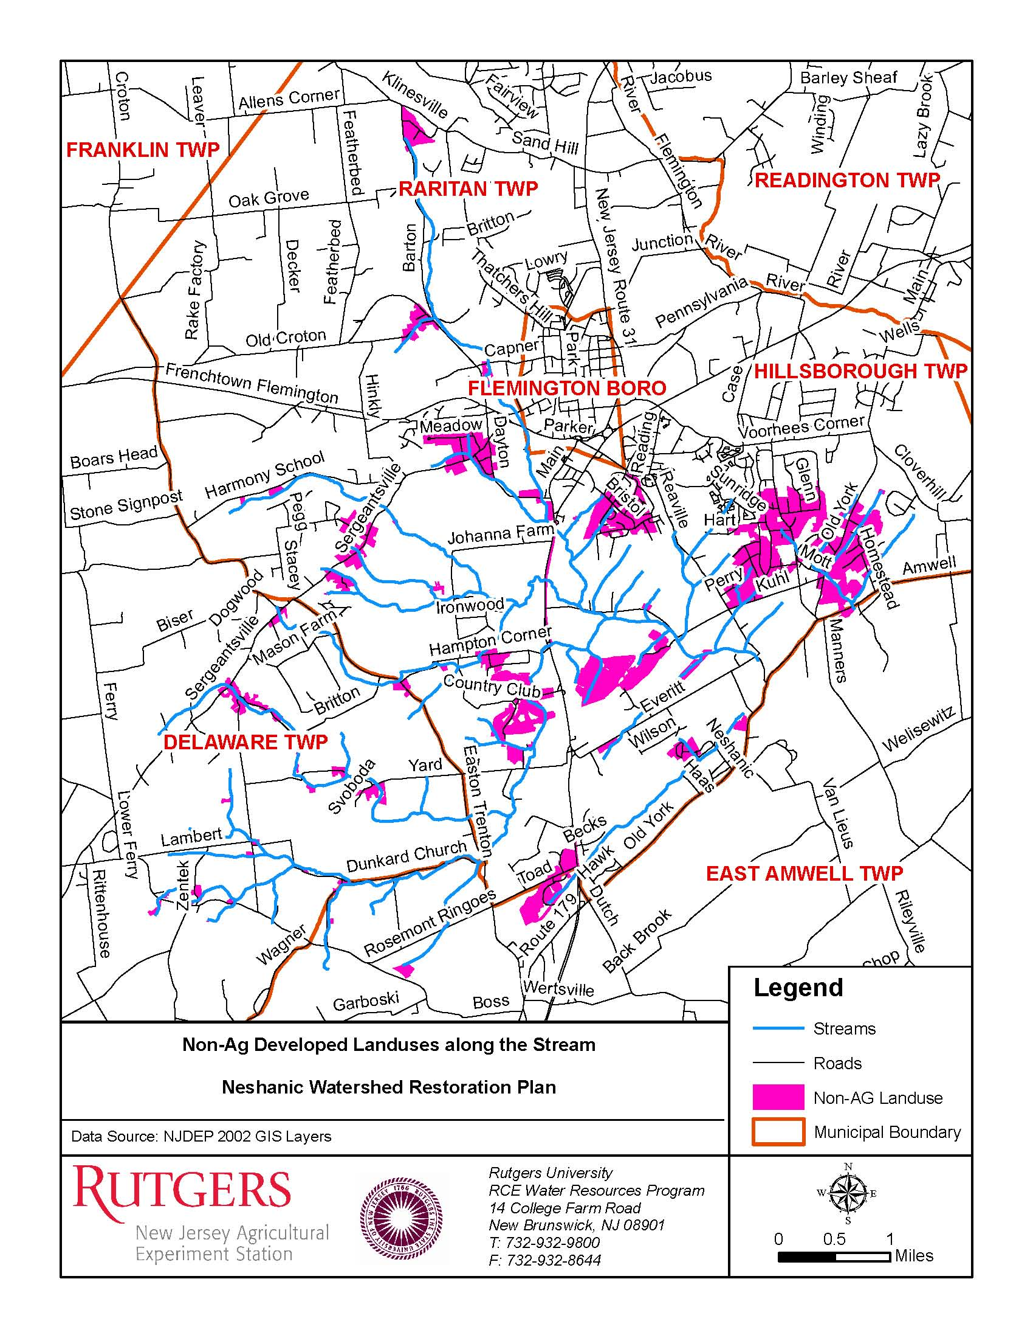

For streams that have multiple sampling locations, the upstream load was subtracted for the downstream station load to determine the pollutant load that is specifically contributed by the watershed located between the two sampling stations.

